**UNIVERISTY OF VIRGINIA CHEMICAL SAFETY AND WASTE TRAINING**

This course is required by the University’s Office of Environmental Health and Safety prior to any chemicals being used in University laboratory spaces. This is an annual training. This format has been designed for non-UVA researchers to complete the course.

This course is designed as a self-taught, honor-based course. All questions must be answered correctly in order to consider this course “passed”. Upon completion of the course, please fill out the Course Completion Confirmation sheet and mail or fax to:

**Arthur Schwarzschild**

**UVA ABCRC**

**PO Box 55**

**Cheriton, VA 23310**

**Fax # 757-331-2371**

**arthur@virginia.edu**

Completed forms must be received no later than your first day at the UVA Anheuser-Busch Coastal Research Center. If you have any questions regarding this process, please call Art Schwarzschild at 757-331-1246.

**UNIVERSITY OF VIRGINIA CHEMICAL SAFETY AND WASTE TRAINING COURSE COMPLETION CONFIRMATION:**

**I certify that I have completed the University of Virginia’s Chemical Safety and Waste Training course on ____/____/2008. I understand that by signing this agreement without actual completion of the course I will be in violation of the University of Virginia’s Honor Code.**

**Name:_____________________________________________**

**Signature:__________________________________________**

**Employer/Institution:________________________________**

**Address:___________________________________________**

**___________________________________________**

**___________________________________________**

**Phone Number:_____________________________________**

**E-mail:____________________________________________**

Chemical Safety and Waste Training

I. What is a Hazardous Chemical?

OSHA defines a hazardous chemical as a substance for which there is statistically significant evidence, based on at least one scientific study, showing that acute or chronic harm may result from exposure to that chemical. Any product or chemical which could meet this definition will have a Material Safety Data Sheet (MSDS) which provides details on the hazards.

**A more appropriate definition of a hazardous chemical would be the following....**

Any substance or mixture of substances which (i) is toxic, (ii) is corrosive,(iii) is an irritant, (iv) is a strong sensitizer, (v) is flammable or combustible,or (vi) generates pressure through decomposition, heat or other means, if such substance or mixture of substances may cause substantial personalinjury or illness during or as a result of handling or use.

Does Your Lab/Department use Hazardous Chemicals?

A list of hazardous chemicals used by each lab/department/cost center may be kept in the respective labs/departments/cost center. A general list of specific hazardous chemicals found across UVA grounds is included in Appendix A of the **Written Hazard Communication Program**, Appendix B contains a general chemical inventory list form which may be used by labs, departments and cost centers.

Top of Form

Chemical Safety and Waste Training

II. Material Safety Data Sheets

Material Safety Data Sheets (MSDS) are the backbone of the UVa Chemical Safety Program. OSHA requires chemical manufacturers and importers to produce one MSDS for each hazardous chemical they manufacture or import. MSDS for the chemicals used where you work, may be kept in your work area, as your supervisor. MSDS are also maintained at OEHS. MSDS will provide more detailed health and property information than is provided on individual container labels. **Faculty, staff and students can get copies of MSDS, and get questions answered about MSDS, in the following ways:**

1. **Call UVA's Office of Environmental Health and Safety (982-4911, if after hours a message will direct you to emergency contact information).**
2. **Fax MSDS requests to UVA's Office of Environmental Health and Safety (982-4915, 8am to 5pm).**
3. **Email MSDS requests to Adam Peters app5a@virginia.edu.**
4. **Come to the OEHS (Special Materials Handling Facility, 515 Edgemont Road) in person.**

MSDS will tell you of any special procedures that may be required for the safe handling of a specific substance. If you are taking any medications, if you are pregnant or if you have a medical condition such as an allergy talk with your supervisor or physician for specific instructions.

When using MSDS you must apply your own good professional judgment to the information that they contain. MSDS are a valuable source of information when you have questions or concerns about any chemical that you work with. It is a good idea to consult the MSDS for any new chemical that is introduced into your work routine, this is a quick and easy way to familiarize yourself to any hazards or precautions that you should take when working with a new substance.

The same MSDS may be used for similar mixtures with essentially the same hazards and contents.

**Definitions of some things that you will find on MSDS:**

* **Irritants --** A non-corrosive chemical which may cause a reversible inflammation effect on living tissue by chemical action at the site of contact.
* **Sensitizers --** A chemical that, after repeated exposure, causes a substantial proportion of exposed people or animals to develop an allergic reaction in normal tissue.
* **Hepatoxins --** Chemicals that cause liver damage; Signs and symptoms include: Jaundice and Liver enlargement; chemicals include but are not limited to: Carbon Tetrachloride, Nitrosamines, Chloroform
* **Nephrotoxins --** Chemicals that cause kidney damage; Signs and symptoms include: Edema, Proteinuria; chemicals include but are not limited to: Halogenated Hydrocarbons, Acetonitrile
* **Neurotoxins --** Chemicals that cause damage to the nervous system; Signs and symptoms include: Narcosis, Behavioral changes, Decrease in motor function; chemicals include but are not limited to: Mercury, Carbon Disulfide, Acrylamide
* **Substances which act on the blood or hematopoietic system --** Signs and symptoms include: Cyanosis, Loss of consciousness; chemicals include but are not limited to: Carbon Monoxide, Cyanides
* **Substances which cause damage to the lungs --** Signs and symptoms include: Cough, Tightness in chest, Shortness of breath; chemicals include but are not limited to: Silica, Asbestos
* **Substances which cause damage to the dermal layer of the body --** Signs and symptoms include: Defatting of the skin, Rashes, Irritation; chemicals include but are not limited to: Ketones, Chlorinated compounds

Faculty, staff and students are encouraged to send copies of MSDS that they receive, to the Office of Environmental Health and Safety, so they may be kept on file and available to emergency personnel and others who may require the information! **Send copies to P.O. Box 400322 or fax to (434) 982-4915.**

Top of Form

Question 1:   
**If you have chemical safety or waste questions who should be contacted for assistance?**  
A. Nuclear Regulatory Commission (NRC)  
B. Centers for Disease Control (CDC)  
C. Virginia Commission on Infectious Agents (VCIA)  
D. UVA's Office of Environmental Health and Safety (982-4911) 

Question 2:   
**The Chemical Hygiene Standard Standard (29 CFR 1910.1450) applies to employees whose occupational exposure may include:**  
A. Hazardous chemicals  
B. Research animals  
C. Human blood, human body fluids, unfixed human tissues, human cell lines  
D. All of the above 

Question 3:   
**Where can you get copies of Material Safety Data Sheets?**  
A. Call UVA's Office of Environmental Health and Safety (982-4911)  
B. Fax MSDS requests to UVA's Office of Environmental Health and Safety (982-4915).  
C. Email MSDS requests to Adam Peters app5a@virginia.edu  
D. All of the above  


Bottom of Form

 Chemical Safety and Waste Training

III. Chemical Labeling

**Labels ARE the primary, initial source of warning for faculty, staff and students** when handling hazardous chemical substances. Federal and State regulations mandate that all labels on original/stock containers of hazardous chemicals include the name of the hazardous chemical, appropriate hazard warning(s) and the name and address of the manufacturer, importer or other responsible party.

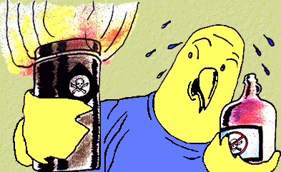

Substances regulated by a **specific** OSHA standard must be labeled by the manufacturer according to the requirements of that standard. **AN EXAMPLE....**

* OSHA 1910.1018(p) -- The Inorganic Arsenic Standard states that containers of inorganic arsenic must have a label which bears the following information:

DANGER  
CONTAINS INORGANIC ARSENIC  
CANCER HAZARD  
HARMFUL IF INHALED OR SWALLOWED  
USE ONLY WITH ADEQUATE VENTILATION

Proper Chemical Labeling

Faculty members and/or Laboratory supervisors MUST ensure that all **incoming containers** of hazardous materials bear a label specifying the following:

1. Appropriate hazard warnings.
2. Identification of the chemical in the container and identification of the hazardous component(s).
3. Name, address and telephone number of the chemical manufacturer, importer or responsible party (e.g. principal investigator/faculty member).
4. Date of receipt or generation of the chemical.

Laboratory workers **should not remove or deface** labels on containers of hazardous chemicals.

When chemicals are transferred from the manufacturer's original container to a secondary container, that new container should be appropriately labeled as to chemical identity and hazard warning(s).

Chemical Labeling -- Hazard Information

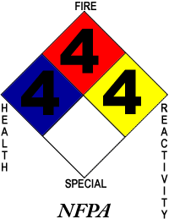

Hazard warnings found on the labels of hazardous chemical containers may be composed of **pictures**, **symbols**, and **words** or any combination thereof which convey the hazard(s) of the chemical.

Picture Hazard Warnings

**Picture hazard warnings help to identify the following  
properties and classes of hazardous compounds.  
  
Here are a few EXAMPLES....**

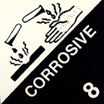 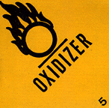 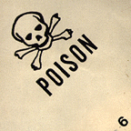

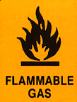  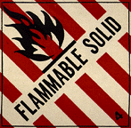 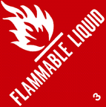

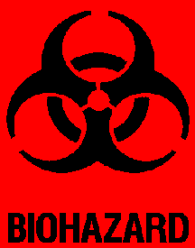 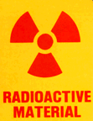 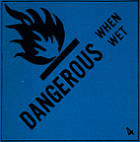 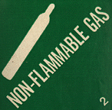

Symbol Hazard Warnings

**Symbol hazard warnings provide basic information in  
determining what precautionary measures to use when handling  
hazardous chemical substances and/or dealing with a fire.**

|  |
| --- |
| The National Fire Protection Association (NFPA) uses a symbol system designed as a diamond-shaped label containing four differently colored squares. **A number (0 - 4) is added to each square indicating the order of hazard severity.**  nfpa-b3 |
| BLUE DIAMOND HEALTH HAZARD  **4 - Deadly 3 - Extreme Danger 2 - Hazardous 1 - Slightly Hazardous 0 - Normal Material** |
| RED DIAMOND FIRE (FLAMMABILITY)  **4 - Flash Point Below 73 oF 3 - Flash Point Below 100 oF  2 - Flash Point Above 100 oF, not exceeding 200 oF  1 - Above 200 oF 0 - Will Not Burno** |
| YELLOW DIAMOND REACTIVITY  **4 - May detonate 3 - Shock and heat may detonate 2 - Violent chemical change 1 - Unstable if heated 0 - Stable** |
| WHITE DIAMOND SPECIAL HAZARDS  Oxidizer - **OX** Use NO WATER - **W with a slash through it** |

Word Hazard Warnings

Word hazard warnings contain a word or words intended to capture the worker's immediate attention **(e.g. flammable, poison, fatal if swallowed)**. These word labels should be in English, but other languages may be used where needed.

**Signal words -** are warnings used to designate the degree of hazard.

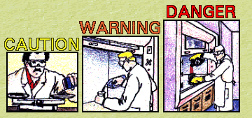

|  |  |
| --- | --- |
| **Signal Word** | **Degree of Hazard** |
| **DANGER** | ***Highest degree of hazard (Red Text)*** |
| **WARNING** | ***Intermediate degree of hazard (Orange Text)*** |
| **CAUTION** | ***Lowest degree of hazard (Yellow Text)*** |

Top of Form

Bottom of Form

Chemical Safety and Waste Training

IV. Flammables

   

**Flammability** is a measure of how easily a gas, liquid or solid will ignite and how quickly the flame, once started, will spread. The more readily ignition occurs, the more flammable the material. Flammable liquids themselves are not flammable; rather, the vapor from the liquids are combustible. There are two physical properties of a material which indicate its flammability: flash point and volatility.

The **flash point** of a material is the temperature at which a liquid (or volatile solid) gives off vapor in quantities significant enough to form an ignitable mixture with air. Given an external source of ignition (i.e., spark, flame), a material can ignite at temperatures at or above its flash point. The flash point of ethyl ether, a highly flammable solvent, is -49 oF; kerosene has a flash point between 100 and 150 oF. Flammable gases have no flash point, since they are already in the vapor stage.

The **volatility** of a material is an indication of how easily the liquid or solid will pass into the vapor stage. Volatility is measured by the boiling point of the material -- the temperature at which the vapor pressure of the material is equal to the atmospheric pressure. The term volatility is often mistakenly used as a synonym for flammability. There are some materials that are volatile but not flammable, such as water, chloroform and mercury.



Some materials are **pyrophoric**, meaning that they can ignite spontaneously with no external source of ignition. Potassium metal, for example, can react with the moisture in air. This reaction causes hydrogen gas to be evolved and the heat generated by the reaction can be hot enough to ignite the hydrogen.

Examples of commonly-used flammable chemicals include but are not limited to the following:

* + acetone
  + ethyl ether
  + sodium
  + hydrogen
  + lithium
  + acetylene
  + ethyl alcohol
  + potassium

Labeling and Information of Flammable Chemicals

* The label indicating flammability is represented by a flame.
* Flammability information can be found in the Material Safety Data Sheet under **Fire and Explosion Data**. Flash point and boiling point information can be found in the section entitled **Physical Properties**.

Storage of Flammable Chemicals

* Flammable materials should never be stored near acids.
* Storage areas should be cool enough to prevent ignition in the event that vapors mix with air. Adequate ventilation should be provided to prevent vapor build up.
* Avoid storage of flammable materials in conventional (non-explosion proof) refrigerators. Sparks generated by internal lights or thermostats may ignite flammable material inside the refrigerator, causing an extremely dangerous explosion hazard.
* Store in a cool, dry, well-ventilated area, out of direct sunlight. Protect from extreme temperatures and rapid temperature changes.
* DO NOT SMOKE near flammables.
* Storage areas should have spill cleanup materials and proper fire fighting equipment nearby. Portable fire extinguishing equipment should include dry chemical, foam or carbon dioxide extinguishers.
* Storage areas should be inspected periodically for deficiencies and storage of flammable materials should be kept to a minimum.
* Flammable liquids can be separated into categories based on their flash point and boiling point. Based on these classifications, OSHA has published permissible limits for specific flammable liquid storage containers.

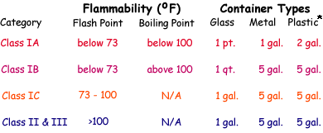

**\*U.L. Approved Plastic Safety Can**

Handling of Flammable Chemicals

* Use gloves and safety goggles when handling flammable liquids or vapors.
* Dispensing of flammable or combustible liquids should only be carried out under a fume hood or in an approved storage room.
* When transferring or using a flammable liquid, all ignition sources should be eliminated from the area. **Open flames or hot plates should NOT be used to directly heat flammable liquids**.
* **DO NOT** use water to clean up flammable liquid spills.
* **DO NOT** dispose of flammable or combustible liquids in the sink or drain. Follow collection procedures issued by OEHS.

Top of Form

Question 1:   
**If the number 4 is displayed in the red diamond (fire/flammability) on the National Fire Protection Association diamond-shaped label this denotes that the material has a flash point of:**  
A. Below 73 oF  
B. Below 100 oF, not exceeding 200 oF  
C. Above 200 oF  


Question 2:   
**Faculty members and/or Laboratory supervisors MUST ensure that all incoming containers of hazardous materials bear a label specifying the following:**  
A. Appropriate hazard warnings  
B. Identification of the chemical in the container and identification of the hazardous component(s)  
C. Name, address and telephone number of the chemical manufacturer, importer or responsible party (e.g. principal investigator/faculty member)  
D. All of the above 

Question 3:   
(True or False) **The label indicating flammability is represented by a flaming letter "O":**  
True  
False  


Bottom of Form

Chemical Safety and Waste Training

V. Corrosives

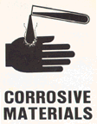 

Gases, liquids and solids can exhibit the hazardous property of **corrosivity**. **Corrosive materials** can burn, irritate and destructively attack living tissue. When inhaled or ingested, lung and stomach tissue are affected.

**Corrosive gases** -- are readily absorbed into the body through skin contact and inhalation.

**Corrosive liquids** -- are frequently used in the laboratory and have a high potential to cause external injury to the body.

**Corrosive solids** -- cause delayed injury. Because corrosive solids dissolve rapidly in moisture on the skin and in the respiratory system, the effects of corrosive solids depend largely on the duration of contact.

Materials with corrosive properties can be either **acidic** (low pH) or **basic** (high pH).

Examples of commonly-used corrosives include but are not limited to the following:

* + sulfuric acid
  + hydrochloric acid
  + nitric acid
  + ammonium hydroxide
  + sodium hydroxide
  + chromium trioxide

Labeling and Information of Corrosive Chemicals

* The corrosive label depicts the corrosion of a hand and/or a bar of steel.
* Information on corrosivity can be found in the Material Safety Data Sheet under **Health Effects and First Aid**.

Storage of Corrosive Chemicals

* Segregate acids from bases and corrosive materials from both organic and flammable materials.
* Store corrosive materials near the floor to minimize the danger of falling from shelves.
* Store in cool, dry, well-ventilated areas, away from sunlight. The storage area should not be subject to rapid temperature changes.

Handling of Corrosive Chemicals

* Wear adequate protective equipment (lab apron, rubber gloves and splash-proof eye protection). If splashing is a definite hazard, face shields must also be worn.
* Corrosive materials should be handled in a fume hood to protect from the possible generation of hazardous or noxious fumes.
* Add reagents slowly. Always add acids to water (**never water to acid**). During the addition of reagents, allow acid to run down the side of the container and mix slowly.
* Corrosive materials should be transported and if possible purchased in unbreakable containers.
* ***If a corrosive chemical comes into contact with your skin or eyes flush the affected area with plenty of water. Flush skin with water for at least 5 minutes and eyes for at least 15 minutes. Seek medical attention as appropriate.***

Top of Form

Bottom of Form

Chemical Safety and Waste Training

VI. Explosives

Explosive materials are chemicals that cause a sudden, almost instantaneous release of large or small amounts of pressure, gas and heat when subjected to sudden shock, pressure or high temperature.

Some substances, under certain conditions of shock, temperature or chemical reaction, can explode violently. Such explosions present many hazards to laboratory personnel.

* + Flying glass can seriously lacerate skin.
  + Fires can result from burning gases.
  + Corrosive or toxic substances can be liberated.

Before working with explosive materials, understand their chemical properties, know the products of side reactions, the incompatibility of certain chemicals and monitor possible environmental catalysts (such as temperature changes).

Examples of commonly-used explosive chemicals include but are not limited to the following:

* + acetylene
  + azide
  + hydrogen
  + nitro compounds
  + ammonia
  + halogens
  + oxygen
  + perchlorates

Labeling and Information of Explosive Chemicals

Information on explosives can be found in the Material Safety Data Sheet under **Fire and Explosion Data**.

Storage and Handling of Explosive Chemicals

Explosion hazards. Examples of things to AVOID....

* + allowing picric acid to dry out
  + mixing flammable chemicals with oxidants
  + flammable gas leaks
  + heating compressed or liquefied gas
  + uncontrollable fluctuating temperatures during experiments using explosive chemicals
  + bringing hot liquid (e.g., oil) into sudden contact with a material possessing a lower boiling point
  + contacting flammable materials with catalysts (e.g., acids or bases catalyze an explosive polymerization of acrolein)
  + explosive peroxide decomposition products from building up in solvent containers during storage
  + mixing nitric acid with acetone
  + distilling ethers unless free from peroxides

**Carefully plan a procedure for working with explosive chemicals.**

* Insert experimental apparatus into a dry glove box or gas blanket.
* Use paper or plastic screw caps on peroxide containers, as friction created by metal screw caps could detonate peroxides.
* Minimize storage of ethers. Date all incoming ether containers. Ethers can be stored for 12 months from the date of arrival if unopened. Opened ether containers can be stored for 1 month. After these effective dates call OEHS for collection of the remaining material.
* Keep specified fire extinguishing equipment near the explosive chemical work space.
* Determine all explosive hazards prior to experimental work, including the stability of reactants/products.

Top of Form

Question 1:   
**The Corrosive label depicts:**  
A. The corrosion of a hand and/or a bar of steel  
B. A flaming letter "O" on a yellow background  
C. A flame on a red background  
D. A skull and crossbones



Question 2:   
**Corrosive materials can:**  
A. Irritate the skin, eyes and other living tissue  
B. Burn the skin, eyes and other living tissue  
C. Destructively attack the skin, eyes and other living tissue  
D. All of the above  


Question 3:   
(True or False) **Information on Explosives can be found in the Material Safety Data Sheet under Fire and Explosion Data:**  
True  
False  


Bottom of Form

Chemical Safety and Waste Training

VII. Oxidizers and Peroxides



An oxidizing agent is a chemical used to provide oxygen for chemical reactions. Oxidizers spontaneously evolve oxygen at room or slightly elevated temperatures and can explode violently when shocked or heated. Because they possess varying degrees of chemical instability, oxidizing agents are explosively unpredictable and, therefore, represent a particularly hazardous safety threat.

Examples of oxidizing agents include but are not limited to the following:

* + peroxides
  + hyperperoxides
  + peroxyesters

Oxidizers can react violently when in contact with organics. For this reason, avoid interactions between oxidizers and organic materials. Examples of organic-reactive oxidizers include nitric acid, chromic acid and permanganates.

Peroxides

Some organic compounds, such as ethers, can react with oxygen from the air, forming unstable peroxides. Peroxide formation can occur under conditions of normal storage, when compounds become concentrated by evaporation or when mixed with other compounds. The accumulated peroxides can then violently explode when exposed to shock, friction or heat. Pure compounds will accumulate peroxides more readily than compounds containing impurities.

**Examples of organic compounds that form hazardous peroxides include but are not limited to the following:**

* + aldehydes, ketones
  + ethers
  + compounds with allylene (CH2 = CHCH2R) structure
  + alkali metals, alkoxides, amines
  + vinyl and vinylidene compounds
  + compounds with benzylic hydrogen atoms

**Examples of chemicals which form hazardous peroxides during exposure to air....**

* + cyclohexane
  + p-Dioxane
  + decalin
  + ethyl ether
  + tetralin
  + isopropyl ether
  + tetrahydrofuran (THF)

Labeling and Information of Oxidizers

* The oxidizer label depicts a flaming letter "O" on a yellow background.
* Information on oxidizing agents can be found in the MSDS under the heading **Reactivity Data**.

Storage and Handling of Oxidizers

* Order ether in small quantities and use quickly.
* Include the date of receipt on containers of peroxidizable compounds. After opening, note the date of use on the label. Peroxidizable compounds can be stored for 12 months from the date of arrival if unopened. Opened containers can be stored for 1 month. After these effective dates call OEHS for collection of the remaining material.
* When possible, store peroxidizable compounds (except certain inhibited vinyl monomers) under a nitrogen atmosphere. Keep away from heat, light and ignition sources.
* Store in a cool, dry, well-ventilated area, out of direct sunlight. Protect from extreme temperatures and rapid temperature changes.
* DO NOT SMOKE near oxidizers.
* Store in amber glass or inert containers, preferably unbreakable. Containers should be tightly sealed and stored in an area with good ventilation. **DO NOT** use corks or rubber stoppers to cap containers.
* Before opening glass bottles, look for the presence of solids (crystals) or viscous liquid at the bottom of the bottle. These are good indicators of peroxide formation. If either are present -- **Do not open container** -- call OEHS for collection (982-4911).
* **Isolate reactive chemicals from....**
  + organic materials
  + flammable solvents
  + corrosives (i.e., nitric, chromic acids)
  + toxicants
* Avoid friction, grinding and all forms of impact while working with oxidizers.
* Discard opened containers of peroxidizable compounds after 1 month. Unopened containers can be stored for 12 months.
* Avoid mixing oxidizing agents with other chemicals during collection procedures.
* Call OEHS for waste collection (982-4911).

Bottom of Form

Chemical Safety and Waste Training

VIII. Poisons

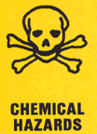  

A poisonous compound is a substance that causes death or serious injury in the event that relatively small amounts are inhaled, ingested or have contacted the skin. All substances can be poisonous in varying quantities (e.g., a little cyanide or a lot of toothpaste).

Labeling and Information of Poisons

* Any substance that carries the international poison symbol (skull and crossbones) should be treated as hazardous.
* Information on the poisonous nature of chemicals can be found in the MSDS section **Health Hazard Data**.

Storage and Handling of Poisons

* Treat poisonous compounds with extreme caution. Wear protective lab coats, gloves and safety glasses and work in a well-ventilated fume hood.

Top of Form

Question 1:   
(True or False) **Oxidizers spontaneously evolve oxygen at room or slightly elevated temperatures and can explode violently when shocked or heated:**  
True  
False  


Question 2:   
**The Oxidizer label depicts:**  
A. A skull and crossbones  
B. The corrosion of a hand and/or a bar of steel  
C. A flame on a red background  
D. A flaming letter "O" on a yellow background

Bottom of Form

Chemical Safety and Waste Training

IX. Carcinogens, Mutagens and Teratogens

A carcinogen is an agent capable of causing cancer, as designated by the Occupational Safety and Health Administration (OSHA). The list of designated carcinogenic chemicals is constantly being modified. Long-term exposure to carcinogenic substances can result in cancers of various types. A number of substances have been found to be capable of producing cancer following exposure by inhalation, ingestion or skin contact.

The Principal Investigator/Faculty Member has overall responsibility for ensuring the safe use, labeling and proper waste collection of carcinogenic chemicals. Employees wishing to work with regulated carcinogens are to notify their Principal Investigator/Faculty Member. In addition, WorkMed should be provided with a list of employees handling any chemicals labeled as carcinogenic.

Labeling and Information of Carcinogens

**The following terms are used to describe carcinogenic materials:**

* **Sufficient positive** -- Those chemicals that were found to promote and increase incidence of malignant tumor in a multiple species or strain of lab animals.
* **Limited positive** -- Those chemicals found to promote either malignant tumors in a single strain or benign tumors in single or multiple species or strain.
* **Inadequate** -- Insufficient evidence to make a decision.
* **Equivocal** -- Almost no supporting evidence.
* **Negative** -- (limited or sufficient) significant negative evidence.

**Examples of known or suspected carcinogens are listed below. The risk factor associated with these compounds is high, alternative compounds should be used whenever possible.**

* + 4-Nitrobiphenyl
  + a- and -Naphthylamine *
  + Methylchloromethyl ether
  + 3,3'-Dichlorobenzidine *
  + bis(chloromethyl) ether *
  + Chloroform *
  + Benzidine *
  + 4-Aminodiphenyl
  + Ethyleneimine *
  + -Propiolactone
  + Benzene *
  + Dimethylaminoazobenzene
  + Vinyl chloride *
  + 1,2-dibromo-3-chloropropane *
  + Arsenic
  + Acrylonitrile *
  + N-Nitrosodimethylamine *
  + Formaldehyde *

* Designates a controlled substance (EPA).

Storage and Handling of Carcinogens

* Containers of carcinogens should be clearly labeled and kept in a separate (preferably locked) storage location. Immediate work areas should be clearly demarcated with warning signs.
* All work surfaces on which carcinogens are used should be covered with stainless steel, plastic trays or dry absorbent plastic-backed paper.
* Laboratory supervisors are responsible for training laboratory workers on proper carcinogen handling techniques.
* Each laboratory worker must adhere to proper operations, emergency procedures, monitoring of lab work and required medical examinations. Medical records must be accurately maintained when working with carcinogens.
* Visitors should be notified about carcinogen use in the laboratory work area.

Mutagens

Mutagens are chemical and physical agents that induce mutations in DNA and in living cells. This affects the genetic system in such a way as to cause cancer or hereditary changes in chromosomes. Individuals exposed to chemicals with mutagenic properties may develop genetic damage to the extent that future offspring will be affected.

Two forms of somatic (body/organ) cell interference may be noted.

* + **Leukemia** -- White blood cells are produced far more rapidly than they can be removed from the blood, interfering with normal body functions.
  + **Cancer** -- Cells that do not normally divide during adult life begin to proliferate to the extent that such division displaces or invades normal tissues.

Examples of mutagens....

* + Arsenic
  + Ethidium Bromide
  + Ionizing Radiation (gamma, x-rays)
  + Alkylating agents (e.g., dimethyl sulfate)

Teratogens

Teratogens are chemical and physical agents that interfere with normal embryonic development. Teratogens differ from mutagens in that there must be a **developing fetus**. Damage to the fetus (embryo) is most likely to occur **early in pregnancy**, during the first 8 - 10 weeks. Teratogens may produce congenital malformations or death of the fetus without inducing damage to the pregnant woman.

In general, carcinogenic, mutagenic and teratogenic chemicals should be considered as hazards to reproductive health. Even though OSHA has established exposure limits of dangerous materials, a developing fetus may be adversely affected by lower doses than those considered "safe". Toxicology is still not well developed to evaluate reproductive health hazards.

As of 1985, OSHA has identified three substances as teratogens.

* + Dibromochloropropane
  + Lead
  + Ethylene oxide

Examples of several other materials that are thought to be associated with reproductive health disorders are listed below.

* + Antimony
  + Carbon disulfide
  + Ethylene thiourea
  + Polychlorinated biphenols (PCBs)
  + Nitrous oxide
  + Formaldehyde
  + Ethylene dibromide
  + Ionizing radiation

Handling and Storage of Mutagenic and Teratogenic Compounds

* Before working with suspected or known mutagenic or teratogenic compounds, obtain health hazard information for each compound. In addition, compile spill cleanup emergency procedures for your laboratory. For more information, call OEHS (982-4911).
* Exercise extreme caution, as you would with carcinogens. Wear personal protective clothing and equipment and work in a well ventilated area.

Top of Form

Question 1:   
**When working with carcinogenic chemicals which of the following MUST be done:**  
A. Containers of carcinogens should be clearly labeled and kept in a separate (preferably locked) storage location  
B. Laboratory supervisors are responsible for training laboratory workers on proper carcinogen handling techniques  
C. Immediate work areas should be clearly demarcated with warning signs  
D. All of the above 

Question 2:   
**Substances have been found to be capable of producing cancer following exposure by:**  
A. Inhalation  
B. Ingestion  
C. Skin contact  
D. All of the above

Chemical Safety and Waste Training

X. Compressed Gases

The purpose of this section is to assist the laboratory worker with identification, storage, maintenance and handling of compressed gases. Compressed gases can be hazardous because each cylinder contains large amounts of energy and may have high flammability and toxicity potential.

Labeling and Information of Compressed Gases

**Compressed gas containers may be labeled in one of five ways:**

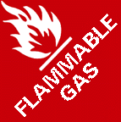

**Flammable Gas** labels show a flame on red label. Flammable gases are materials that, when released at ambient temperature and pressure, mixes with air to form a flammable mixture.

**Non-flammable Gas** labels depict a gas canister on a green background. Nonflammable gases are materials that are not flammable. The contents of a nonflammable gas cylinder are not necessarily "non-reactive". With most nonflammable gas cylinders the greatest hazard is asphyxiation or the rupturing of the cylinder.

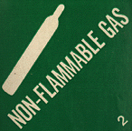

**Poisonous Gas** labels show a skull and crossbones. Avoid all contact with gases from cylinders labeled as poison gas, the gas is very likely to be highly toxic, irritating or corrosive or a combination of these. Inhaled poisonous gases can act locally on the mucous membranes of the respiratory tract (either being absorbed here or causing damage such as swelling or irritation). These gases can also be taken into the lungs, causing both localized damage to the lungs and systemic injury when absorbed by the body.

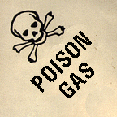

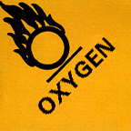

**Oxygen-containing Gas** labels are designated by a flaming letter "O". Oxygen is nontoxic under normal conditions and is nonflammable. Oxygen is, however; a powerful oxidizing agent and can vigorously accelerate combustion. In the presence of oxygen, some materials that are noncombustible under ordinary circumstances will burn.

**Chlorine Gas** labels are distinctly marked. Chlorine is highly corrosive and irritating to the eyes, skin, mucous membranes of the nose and throat and to the lungs. Avoid breathing chlorine gas under any circumstances. Chlorine is a strong oxidizer and will react with many substances and, like oxygen, chlorine will support the combustion of many flammable substances.

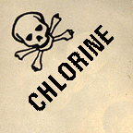

* Know the contents of the cylinder and be familiar with the properties of the gas.
* The contents of the cylinder or compressed gas should be clearly marked and identified with proper labels or tags on the shoulder of the cylinder. Those cylinders or compressed gases that do not comply with identification requirements should be returned to the manufacturer.
* If two labels are associated with one cylinder, affix the labels 180o apart on the shoulder of each cylinder. Label all empty cylinders **EMPTY** or **MT** and date the tag.
* All regulators, gauges, valves and manifolds must be designed for the particular pressures and gases involved. They should bear the inspection seal of either Underwriters' Laboratories (UL) or Factory Mutual Engineering Division of Associated Factory Mutual Fire Insurance Companies (FM).

Storage and Handling of Compressed Gases

* All cylinders should be stored in cool, dry, well-ventilated surroundings and away from all flammable substances including oil, greases and gasoline. **DO NOT** subject any part of a cylinder to a temperature higher than 125 oF.
* Cylinders should not be located where objects may strike or fall on them.
* Cylinders should not be stored in damp areas, near salt, corrosive chemicals, fumes, heat or direct sunlight. Store cylinders by gas type, separating oxidizing gases from flammable gases.
* All cylinders and compressed gases (full or empty) should be properly fastened and supported by straps, belts, buckles, or chains to prevent them from falling and causing bodily harm. A maximum of two cylinders per restraint is preferred.   
    
    
    
  DO NOT SMOKE  
  in areas where there are flammable  
  gases being used or stored.

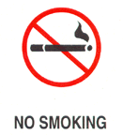

* **DO NOT** extinguish a flame caused by a gas until the gas source has been shut off.
* A cylinder should only be moved while strapped to a wheel cart to ensure stability. When storing or moving cylinders, always attach safety caps.
* **DO NOT** heat the cylinder or place a cylinder where it may become part of an electrical circuit. Compressed gases must be handled as high-energy sources and dangerous projectiles.
* All cylinders should be checked for damage prior to use. **DO NOT** repair damaged cylinders yourself. Damaged or defective cylinders, valves, etc., must be taken out of use immediately and returned to the manufacturer for repair.
* Each regulator valve should be inspected annually. Never force valve or regulator connections. Threads and the configuration of valve outlets are different for each family of gases to prevent mixing of incompatible gases.
* **DO NOT** use lubrication on valve regulators.

Top of Form

Chemical Safety and Waste Training

XI. Cryogenic Materials

Cryogenic materials have special properties that make them particularly hazardous to use in the solid, liquid or gaseous state.

Storage and Handling of Cryogenic Materials

* The severely cold temperatures associated with cryogenic liquids (-60 oC to -270 oC) can damage living tissue on contact and embrittle structural materials.
* Liquefied under pressure, cryogenic liquids must be kept in specially designed, high-pressure vessels that contain fittings to relieve pressure. When in contact with a moist area, ice formation can plug pressure release devices and pose an explosion hazard. For this reason, store vessels in a dry place and periodically check for ice formation.
* Cryogenic liquids present fire and explosion hazards. A flammable mixture, cooled in the presence of air with liquid nitrogen or liquid oxygen, can cause oxygen to condense and thereby present an explosion hazard. Keep away from ignition sources. Flammable liquids will support combustion in both the liquid and gaseous states. If allowed to depressurize, cryogenic liquids will rapidly and violently expand.
* Store and work with cryogenic liquids in a well-ventilated area. These liquids can cause asphyxiation as evaporating CO2 is concentrated around cryogenic materials.
* Safety glasses and face shields should be used. For handling of cryogenic liquids, use potholders instead of gloves (as gloves can freeze to the skin).
* Cushion glassware in a protective covering to prevent injury caused by flying glass in the event of implosion/explosion.
* Transport fragile cryogenic containers with caution -- use a hand truck.

Top of Form

Chemical Safety and Waste Training

XII. Chemical Storage

Here are some useful tips for the safe storage of chemicals in the laboratory.

1. Label all containers. **UNLABLED CONTAINERS MAY RESULT IN A CITATION FOR VIOLATING STATE AND FEDERAL HAZARDOUS WASTE REGULATIONS!**
2. Chemicals should have a definite storage place and be returned to that location as soon as possible.
3. Chemicals should **NEVER** be stored in the following places:
   * a high place (out of the line of vision) or anywhere else where they will be hard to see or reach
   * a laboratory fume hood
   * exits, passageways, empty spaces under tables or benchtops or places where emergency equipment is stored
4. Volatile toxic chemicals and odoriferous chemicals should be stored in a ventilated cabinet. Call OEHS 982-4911 for assistance.
5. Keep stored chemicals away from heat or direct sunlight.
6. **DO NOT** store incompatible chemicals together.
7. Separate chemicals into compatible groups. Within each group, store the chemicals alphabetically.
8. Flammable liquids should be stored in an approved flammable liquid (usually painted yellow) cabinet.
9. Storage outside chemical storage cabinets should be kept to a minimum.
10. The vent cap on chemical storage cabinets should not be removed from its location unless the cabinet is attached to an existing ventilation system.
11. Glass containers should be stored on the bottom shelf of storage cabinets (if at all possible).

Top of Form

Chemical Safety and Waste Training

XIII. Chemical Exposure

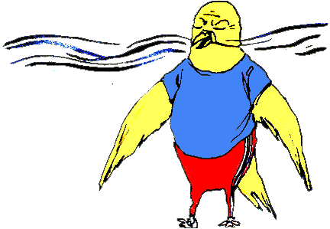

**There are many ways in which you may be exposed to chemicals in the laboratory or in your work area. Here are the primary routes of chemical exposure....**

**Routes of Chemical Exposure**

* **Inhalation** - Gases, vapors of volatile liquids, mist and sprays from liquids, particles from solid chemicals, fibers and dusts are all materials that may enter the body via inhalation. The inhaled material can act locally to damage the mucous membranes of the mouth, throat and lungs. The inhaled material may be directly absorbed through the mucous membranes and into the body or can pass into the capillaries of the lungs and be carried into the circulatory system. Your lungs have a surface area equal to the surface area of a tennis court. This is quite a large surface area in your chest exchanging molecules from the blood to the air and vice versa, the absorption of molecules from the air to the blood stream can be quite rapid.
* **Ingestion** - Many chemicals can be harmful, even fatal, if they enter the mouth and are swallowed. After ingestion, a chemical may act locally to cause irritation and burns to the mouth throat and stomach or the chemical may be absorbed into the blood and cause systemic injury.
* **Contact with the Skin** - Chemical contact with the skin can be a frequent mode of injury in the laboratory. Contact with the skin by certain chemicals can produce irritation and allergic reactions. Corrosive chemicals can cause minor to very serious burns to the skin, while other chemicals may be directly absorbed through the skin in sufficient quantities to produce systemic toxicity.
* **Contact with the Eyes** - The eyes are so sensitive that very few substances **don't** cause irritation when they come into contact with the eyes. The eyes contain a large number of blood vessels which can be a route for direct chemical absorption into the body.
* **Cuts/Punctures/Injections** - Always take care when using sharp instruments (needles, scalpels, etc...). When using capped glass vials or tubes use care when either capping or uncapping, they can break and form very sharp edges. Cutting yourself or puncturing your skin with a needle may result in you being exposed to a chemical, this is one of the most dangerous routes of exposure since a chemical may be directly injected into the bloodstream thus bypassing the process of absorption.

Top of Form

Top of Form

Question 1:   
**Chemicals should NEVER be stored in which of the following places:**  
A. A high place (out of the line of vision) or anywhere else where they will be hard to see or reach  
B. A laboratory fume hood  
C. Exits, passageways, empty spaces under tables or benchtops or places where emergency equipment is stored  
D. All of the above 

Question 2:   
**When storing chemicals one should:**  
A. Store all chemicals together in one place and sort alphabetically  
B. Separate chemicals into compatible groups, and within each group store the chemicals alphabetically  
C. Store all chemicals in a laboratory fume hood  
D. Store chemicals in the hallway if your lab has run out of space 

Question 3:   
**When labeling containers one should:**  
A. Not worry about labeling containers since you know what they contain  
B. Only label containers that contain hazardous chemicals  
C. Only label containers that contain biohazardous agents  
D. Label all containers since an unlabeled container may result in a citation for violating state and federal hazardous waste regulations

  
  
  
  
  
  
  
  
  
  
  
  
  
  
  
  
  
  
  
  
  
  
  
  
  
  
  
  
  
  
  
  
  
  
Chemical Safety and Waste Training

XIV. Toxic Effects of Chemicals

The toxic effects of a chemical may occur in one of three ways:

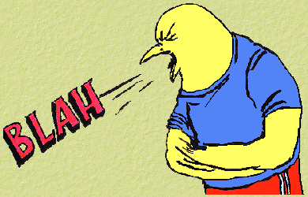

1. **Acute** - Single Exposure
2. **Intermittent** - Repeated Exposure
3. **Chronic** - Long-Term Repeated Exposure

A substance which is acutely toxic can cause damage after a single short-duration exposure. Examples of acutely toxic substances include Hydrogen Cyanide, Hydrogen Sulfide, Nitrogen Dioxide and Nickel Carbonyl.

Intermittent or chronic exposure to toxic substances can cause damage after repeated or long-term repeated exposure respectively. The cumulative damage that low exposures, to a chronic toxin, may not become apparent for many years. Examples of chronic toxins include all carcinogens, reproductive toxins and heavy metals (e.g., mercury and lead).

**Some signs of potential chemical exposure (acute, intermittent or chronic) include:**

* + Do you smell something? An odor in the air.
  + Coughing
  + Headache
  + Fatigue
  + Discolored Stool
  + Blotches on skin
  + Burning sensations in the eyes, nose, mouth and/or throat.
  + Nausea
  + Dizziness

When working in the laboratory it is important for you to know what you are working with so that you can use the substance in a safe and efficient manner thus limiting your potential for exposure.

Toxicity

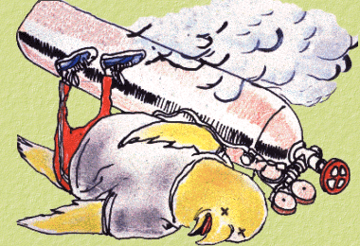

The concept of toxicity is unique because it can be applicable to all chemical substances used in the laboratory. The terminology explained below can not only assist laboratory workers in assessing the degree of hazard, but it can also provide guidance in the selection of appropriate personal protective equipment.

As defined, **toxicity** is the ability of a substance to cause damage to living tissue, impairment of the central nervous system, severe illness or in extreme cases, death when ingested, inhaled or absorbed through the skin.

* The administration of a particular dosage of a chemical, and the subsequent response by experimental animals, can help predict that chemical's toxic effect on humans. The dose-response behavior is represented by a dose-response curve, which demonstrates that not all individuals will respond to a particular dose of a chemical in the same manner. Some people will be more sensitive than others and a specific dosage that may be lethal to one person may not be lethal to another. Therefore, an average measure of toxicity must be denoted.
* The point on the curve where 50% of the test animals have died as a result of a particular chemical dosage is referred to as the Lethal Dose50 or **LD50**. The LD50 is usually indicated in terms of milligrams of substance **ingested** per kilogram of body weight (mg/kg). The lower the LD50, the more toxic the material.
* Inhalation of toxic substances can cause a great deal of tissue damage. Each lung is composed of a large surface area of folded tissue, which would be vulnerable to assault by toxic vapors and airborne particles. The toxicity of a substance via **inhalation** is measured by **TLV's** or threshold limit values. These values are determined by the American Conference of Governmental Industrial Hygienists (ACGIH) and are expressed in parts per million (ppm) of the substance in air or milligrams of substance per cubic meter of air. **There are two major types of threshold limit values: the time-weighted average (TWA) and the short-term excursion limit (STEL).**

**TWA**

* + The **TWA** of a substance is the average concentration to which a worker can be exposed throughout an eight-hour work day without adverse effects.
  + An important point to keep in mind is that the adverse effects of over-exposure to a material can range from headache or nausea to more severe disabilities.
  + For this reason, time-weighted averages should be considered only as a guide in controlling health hazards in the laboratory, not as definitive marks between **safe** and **dangerous** concentrations.

**STEL**

* + The **STEL** of a substance is the maximum amount to which a worker can be exposed in a fifteen-minute period without adverse effects. Again, this is intended only as a rough guideline.
* The toxicity of a substance via **absorption** can be determined several ways. Often, the threshold limit values of a substance will have a skin notation, indicating they are rapidly absorbed by the skin. Absorption can also be indicated by the solubility of the material in water. Materials that are extremely soluble in water can dissolve in skin moisture and be transported through the skin's surface. For instance, dimethyl sulfoxide (DMSO) rapidly absorbs into the skin. If any toxic materials are present in this solvent or on the surface of the skin, DMSO will transport these contaminants into the body as well.

A listing of OSHA-regulated substances and there PEL's (permissible exposure limits), TWA's and STEL's are contained in OHSA 29 CFR 1910.1000 Table Z-1-A, Z-2 and Z-3. Consult your supervisor or OEHS if you have any questions about the chemicals that you work with. Tables Z-1-A, Z-2 and Z-3 are available from OEHS (982-4911).

Top of Form

Chemical Safety and Waste Training

XV. Chemical Exposure to the Skin and Eyes

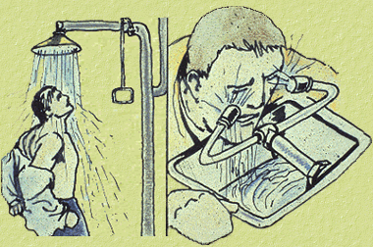

EYES

If you get a chemical in your eye(s) get to an eye-wash, shower or sink. Flush your eyeball and inner surface of eyelid with water continuously for 15 minutes. When you get something in your eye it will most certainly be painful and irritating, you will not want to open your eye to flush it out. If possible call to a co-worker for help, she/he may be able to hold your eyelid open to better flush the eye out. **You must force the eyelid open to ensure effective washing behind the eyelid.** Seek prompt medical attention.

SKIN

If you spill a chemical on your person get to a shower or a sink. **Don't be modest, remove any contaminated clothing immediately and flush the affected area with plenty of water for at least 5 minutes.** Make sure chemical has not accumulated in shoes. If necessary seek medical attention.

Top of Form

Chemical Safety and Waste Training

XVI. Personal Protective Equipment

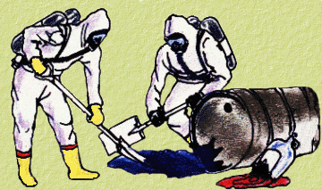  
**You can do many things to protect yourself when working with hazardous chemicals.**

**Contact OEHS (982-4911) if you need assistance in selecting the proper Personal Protective Equipment for your needs.**

**Below are some helpful tips....**

Proper Laboratory Clothing

* Wear long pants.
* Wear long sleeved blouses or shirts.
* Wear closed toe shoes.
* Wear a laboratory coat or apron.
* Confine long hair, loose clothing and jewelry.
* Cotton is the preferred fabric for a lab worker since many synthetic fibers are flammable and may increase the severity of a burn.

Proper Eye Protection

* Safety glasses with side shields offer the minimum protection acceptable for regular use. The American National Standards Institute (ANSI) standard Z87.1-1989, Standard for Occupational and Educational Eye & Face Protection gives specific minimum standards for lens thickness, impact resistance, etc. for safety glasses.
* When working with highly caustic liquids, large volumes of liquids *(spill/splash danger)* or flying particles splash goggles or face shields must be worn.

Contact lenses cannot be substituted for safety glasses since they offer **NO** protection against eye injury. Contact lenses can increase the amount of injury to the eye by concentrating chemical vapors on the eye and by making it difficult to flush the eye out while giving first aid. If a medical reason necessitates the use of contact lenses by a laboratory worker, additional safety glasses with side shields or safety goggles must be worn by the worker.

Proper Glove Selection

Gloves are a simple and effective way to protect yourself whenever handling hazardous chemicals, sharp objects, hot/cold materials, toxic chemicals and chemicals of unknown toxicity. Selection of the proper gloves is very important since no glove material is impermeable to all chemicals.

* Understand the hazards of the chemicals that you work with and choose a glove material that is known to be resistant to permeation by the substance(s) being used.
* Gloves should be inspected for holes and tears prior to use.
* If appropriate, wash gloves before removing them (some gloves are water permeable).
* If at all possible do not touch doorknobs, telephones, pens, keyboards, scales, drawer handles or yourself before you remove your gloves. This will help prevent the unintentional spreading of hazardous substances to yourself and to your fellow co-workers.
* Replace gloves periodically.
* Always wash your hands thoroughly with soap and water before putting gloves on and after taking gloves off.

Top of Form

Chemical Safety and Waste Training

XVII. Emergency Procedures in Case of Bodily Injury

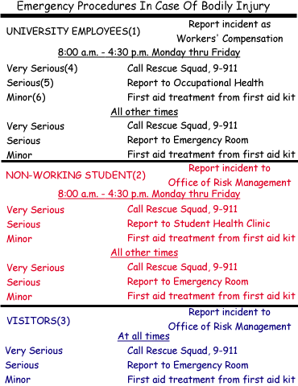

1. **University Employees** includes all regular faculty and classified employees. It also includes all students (e.g., graduate teaching and research assistants, undergraduate graders, etc.) who are performing their work duties at the time of the accident.
2. **Non-working Students** includes all students not receiving any University pay for services rendered and all students who are NOT performing their work duties at the time of the accident.
3. **Visitors** are any persons visiting the University with no pay or non-pay affiliation with the University.
4. **Very Serious Injury**: Patient is unconscious and/or shock and/or bleeding seriously.
5. **Serious Injury**: Patient is in need of skilled medical assistance, but is able to walk.
6. **Minor Injury**: Person sustains minor cut, bruise, etc.

Reporting Chemical Exposure Incidents

Chemical exposure incidents should be reported to the Faculty Member or Supervisor in charge of the Laboratory/Work Area.

Top of Form

Question 1:   
**If you get a chemical in your eye(s) you should:**  
A. Keep rubbing your eye and hope the pain goes away  
B. Find some eyedrops and use them to dilute the chemical  
C. Flush your eyeball and inner surface of eyelid with water continuously for 15 minutes  
D. Do nothing except blink repeatedly until the pain goes away 

Question 2:   
**If you need assistance in selecting the proper Personal Protective Equipment you should contact:**  
A. UVA's Police Department (9-911)  
B. UVA's Office of Environmental Health and Safety (982-4911)  
C. The Charlottesville Fire Department  
D. The Nuclear Regulatory Commission (NRC) 

Question 3:   
**If you think that you have been exposed to a Hazardous Chemical you should:**  
A. Report the incident to the Faculty Member or Supervisor in charge of the Laboratory/Work Area  
B. Seek medical attention, if needed  
C. Both A and B  
D. Do nothing 

Question 4:   
**If you spill a chemical on your person you should:**  
A. Remove any contaminated clothing immediately (Don't be modest!) and flush the affected area with plenty of water for at least 5 minutes, if necessary seek medical attention  
B. Use paper towels to soak up the chemical from you clothes  
C. Do nothing and let the chemical evaporate naturally  
D. All of the above

  
  
  
  
  
  
  
  
  
  
  
  
  
  
  
  
  
  
  
  
  
  
  
  
  
  
  
  
  
  
Chemical Safety and Waste Training

XVIII. Chemical Spills

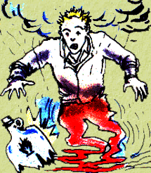

**The procedures described below are to be used for chemical spills of 1 - 2 pints. For spills greater than 2 pints, notify Faculty Member or Supervisor and call 982-4911.**  
  
Locate spill cleanup kits. Laboratories should be equipped with spill cleanup kits. If your laboratory area does not have such emergency items, the supervisor can contact OEHS and we can provide you with a free cleanup kit.  
  
Wear the appropriate personal protective equipment (e.g., gloves, goggles) when cleaning up spills.

Please call the OFFICE OF ENVIRONMENTAL HEALTH & SAFETY (982-4911) if you require assistance in cleaning up a chemical spill.

Acid Spills

1. Apply neutralizer (or sodium bicarbonate) to perimeter of spill.
2. Mix thoroughly until fizzing and evolution of gas ceases. **NOTE:** It may be necessary to add water to the mixture to complete the reaction. Neutralizer has a tendency to absorb acid before fully neutralizing it.
3. Check mixture with Congo Red indicator paper. The red color indicates that the acid has been neutralized.
4. Transfer the mixture to a plastic bag, tie shut, fill out a waste label and place in the fume hood.
5. Notify supervisor and call OEHS for collection.

Solvent Spills

1. Apply activated charcoal to the perimeter of the spill.
2. Mix thoroughly until material is dry and no evidence of solvent remains.
3. Transfer absorbed solvent to a plastic bag, tie shut, fill out and attach a waste label and place in the fume hood.
4. Notify supervisor and call OEHS for collection.

Mercury Spills

1. Dampen the mercury sponge with water, then wipe the contaminated area.
2. Do this procedure slowly to allow for complete absorption of all free mercury. A silvery surface will form on the sponge.
3. Place the contaminated sponge in its plastic bag, tie shut, fill out and attach a waste label and place in the fume hood.
4. Notify supervisor and call OEHS for collection.

Top of Form

Chemical Safety and Waste Training

XIX. Waste Laboratory Glassware and Sharps

1. Laboratory Glassware **NOT** contaminated with blood, body fluids, chemicals or radioactive material belongs in a cardboard box, with a plastic liner, **NOT** in a CMC or Chemical Waste Container. The box must be labeled with a yellow sticker that says...

CAUTION  
WASTE LABORATORY GLASSWARE  
HANDLE WITH CARE

If the glassware is contaminated with chemicals rinse the chemicals off and place the chemicals in the appropriate chemical waste container and dispose of the rinsed "clean" glassware in the cardboard box.

The yellow sticker below is available for your use (free of charge), call OEHS (982-4911), to obtain the labels.

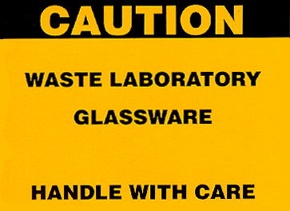

2. **Sharps Disposal**: Sharps must be disposed of in an appropriate **sharps container**.

According to Virginia Law, these 4 items must always be disposed of in an appropriate sharps container regardless of whether it is contaminated:

1. **All Needles**
2. **Syringes with Needles**
3. **Scalpels**
4. **Suture Needles**

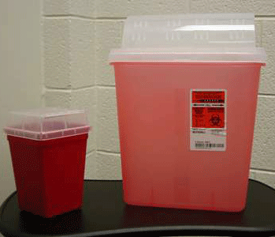

Sharps containers are available from the Hospital Storeroom (243-2928). These containers should not be altered in any way. For example, the lids should not be detached, nor should the plastic shielding be removed.

1 quart container: Bin # 92131 est. cost: $1.17  
2 gallon container: Bin # 92133 est. cost: $2.68

**Other Sharps:** These items must be disposed of in an appropriate sharps container when contaminated with human materials or microorganisms, if NOT contaminated see above:

* Glass Pasture Pipettes
* Cover slips and slides
* Broken glass
* Capillary tubes
* Anything contaminated that can puncture human skin

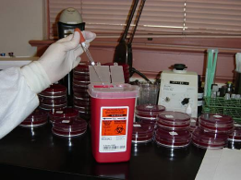

When ¾ full, sharps containers should be sealed. Full containers MUST then be placed into Contaminated Materials Container (CMC) for final disposal.

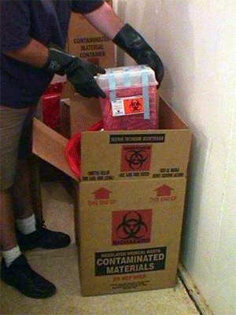

Top of Form

Chemical Safety and Waste Training

XX. Chemical Waste Collection

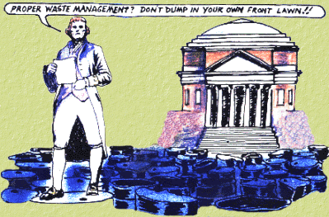

The Environmental Protection Agency (EPA) is closely scrutinizing academic institutions these days. Under EPA regulations, those individuals who continue to dump chemical waste down the drain will face stiff fines and a possible jail term. **This punishment will be levied against the offending laboratory employee, not the University.** All this talk of fines is unnecessary, however, because UVa maintains a user-friendly waste collection program. The Office of Environmental Health and Safety (OEHS) answers waste collection questions and will even pick up your laboratory waste upon request, but we need your help. Take the time to follow the simple guidelines below and call OEHS if you have any questions (982-4911).

Segregation of Chemical Waste

We prefer to keep certain types of chemicals separated at the time of collection. This method not only lowers disposal costs for the University, but also decreases the chances of incompatible materials being added together.

Keep the following groups to themselves whenever possible:

1. **Non-halogenated organic solvents, <5% water**
2. **Non-halogenated organic solvents, >5% water**
3. **Halogenated solvents (% water unimportant)**
4. **Solutions containing compounds of the following metals: arsenic, barium, cadmium, chromium, lead, silver and selenium.**
5. **Any solution containing mercury or its compounds. (Mercury/mercury compounds should be kept separate from any liquid whenever possible.)**
6. **Acids, organic**
7. **Acids, mineral**
8. **Bases, organic**
9. **Bases, mineral**
10. **Acyl Halides (e.g. acetyl chloride, thionyl chloride, benzoyl chloride)**
11. **Cyanides**
12. **Sulfides**
13. **Organic peroxides**
14. **Inorganic Oxidizers**
15. **Photographic fixer**
16. **Photographic developer**
17. **Photographic stop bath**
18. **Water-reactive compounds (e.g. sodium, butyllithium, grignard reagents)**
19. **Pesticides**
20. **Oils**
21. **Paints**
22. **Formaldehyde Solutions**

Do not put acidic or basic waste (pH < 3 or > 9) in metal cans. Metal cans corrode in a very short time. Keep acids and bases separate from hydrocarbons and ethers.

When possible, keep all carcinogens/mutagens separate from other waste. Keep aqueous wastes separate from organic solvents. Keep halogenated solvents and wastes separate from non-halogenated solvents.

Containers and Labels for Chemical Waste

**Do not put hazardous waste down the sink or in the trash**. If you are not sure if a chemical is hazardous, call us (982-4911). OEHS provides the following containers for chemical waste collection, activities requiring special containers are evaluated on a case-by-case basis.   
  
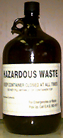4 liter (~1 gallon) plastic-coated glass bottle.  
  
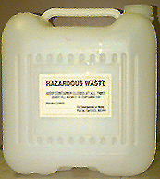5 gallon plastic carboy.  
**This is the preferred (DOT-approved) container for liquid chemical waste.**  
  
  
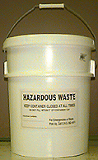5 gallon bucket.  
**The 5 gallon bucket is used for solid and gel waste. Liquid waste should NEVER be put into a bucket like this.**

Chemically contaminated needles should be placed in Sharps-a-gator boxes and will be disposed of by OEHS.

All chemical waste must be deposited in properly labeled waste containers. According to the Virginia Department of Waste Management, each waste container MUST be marked with a **hazardous waste sticker**. Any containers issued by our office will already contain this sticker. If you plan to use your own bottles as waste receptacles, you can receive the required stickers by contacting our office (982-4911). In addition to waste stickers, all waste containers MUST contain a **waste collection label** issued by OEHS. This includes chemicals still in their original containers. Waste will not be picked up if it is not labeled properly. If you need new labels, let us know and we will deliver them on our pickups.

Hazardous Waste Sticker

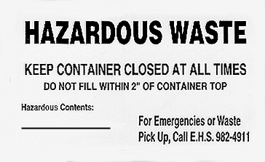

Waste Collection Label

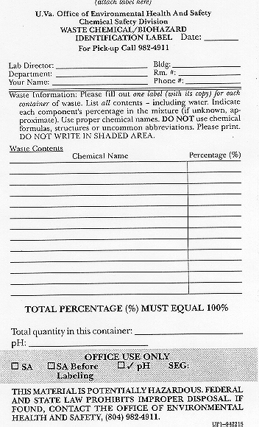

Both the label and its no-carbon-required copy should be affixed to the waste container by a single piece of tape across the top of the label or in such a way that we can remove the copy when we pick up the waste.

Information that is absolutely required  
on the chemical waste label includes....

* 1. The names of **all possible contents**, including stains, water or any solvents. Do not use abbreviations or formulas.
  2. The percentages of each component (the percentages may be approximated but the total MUST equal 100%).
  3. The total quantity.
  4. The pH of the waste liquids if it is suspected to be pH < 3 or pH > 10.
  5. Also include you name, date, department, building and room number where the waste is located, phone number and lab director.

**IMPORTANT:** Disposal companies will not accept unknown chemicals. You must make every possible effort to accurately describe the contents of each container. This means tracking down and questioning previous lab occupants if necessary.

**DO NOT FILL CONTAINERS TO THE TOP**. Fill plastic carboys **ONLY** to the fill line. Leave about 2 inches at the top of all other containers. All waste must reside in closed, non-leaking containers. Do not use flasks or test tubes with stoppers, beakers with parafilm or bottles with ground glass stoppers. The outside of the waste container must be reasonably clean. Do not put liquids (especially phenol) in bottles designed for solids. *They leak*!

The Virginia Department of Waste Management has stated that all chemical waste containers must remain **CLOSED** (capped) between chemical waste additions. When chemical waste containers are left uncapped, laboratory personnel are at the risk of chemical exposure and injury due to inhalation of chemical vapors and potential fire hazard.

Acidic solutions containing **METALS** (arsenic, barium, cadmium, chromium, lead, silver) should **NOT** go in 5-gallon carboys.

We do not pick up empty bottles. They may be triple rinsed and discarded. We will supply empty bottles, as well as 5-gallon cans and carboys. Call in advance for these items and we will bring them with your regular pickup.

**Ethers** tend to form *extremely explosive compounds* over time. Therefore, write the date of receipt and the date of opening on all ether cans. Do not keep an opened ether can for more than 1 month or an unopened can for more than 12 months. If you have an old ether can, label as waste and call OEHS for pick up.



Do not attempt to open any bottles of **DRY picric acid**. This is an **extreme explosion hazard**! Any dry bottles of picric acid should be labeled as waste and picked up by OEHS staff.

Chemical Waste Pick-up

Do not accumulate more than five 5-gallon cans or carboys, or more than ten gallons in bottles. Larger pickups will have to be scheduled separately.

Call 2-4911 to schedule waste pick up. Chemical waste will be picked up within three working days from the date it was called in.

Top of Form

Question 1:   
**All hazardous chemical waste containers must:**  
A. Be kept closed at all times, except when filling  
B. Be marked with a Hazardous Waste Sticker  
C. Include a Waste Collection Label  
D. A, B and C above.  
E. Be poured down the sink when full 

Question 2:   
**For the collection of hazardous chemical waste OEHS will provide which of the following free of charge:**  
A. Containers for your chemical waste  
B. Pick up of your chemical waste within three working days from the date which it was called in for collection  
C. Labels for your chemical waste  
D. All of the above

**Answer Page:**

**Pages 3-4: 1) D, 2) A, 3)D**

**Pages 12-13: 1) A, 2) D, 3) False**

**Pages 17-18: 1) A, 2) D, 3) True**

**Pages 22-23: 1) True, 2) D**

**Page 27: 1) D, 2) D**

**Pages 34-35: 1) D, 2) B, 3) D**

**Pages 43-44: 1) C, 2) B, 3) C, 4) A**

**Page 55: 1) D, 2) D**

