Species-Habitat Associations and Succession Vectors
for Small Mammal and Land Bird Populations on
Assateague Island National seashore

A Final Report Submitted to

Dr. Dan E. Huff

Environmental Specialist
National park Service
Denver Service center

by

Rayrnond D. Dueser
John H. Porter
and
Thomas F. Wieboldt

Department of Environmental sciences
University of Virginia

TABLE OF CONTENTS

Introduction

Study Area

The Transects
1

3

4
Marnirtal Study

Methods

Species Observed

Transect. Summaries

Transect Comparisons ....

Species Summaries

Species-Habitat Associati

Species Accounts

Discussion Bird Study

Methods

Species Observea

Transect Summaries ....

Campground Summaries

Species Summaries

Species-Habitat Associa

Species Acconnts

Discussion
ons
1 4

1 4

1 6

1 8

1 9

2 3

2 5

2 8
tions

35

as

39

4 4

44

48

52

56
Literature Cited
60

INTRODUCTION

Conspicuous zonation is a characteristic feature of barrier island vegetation (Oosting 1954) on large islands, this zonation typically proceeds inland from the ocean beach through several successive zones! foredune grassland, grassland~shrnb, shrub thicket, woodland ana bayshore salt marsh. The plant association of each zone is relatively distinct in species composition, structure and appearance. Depending on topography, the transition between zones may be either abrupt or gradual. Several studies have provided evidence that physical factors such as salt deposition and topographic position exert a dominant influence on plant distributions Coosting and flillings 1942, Oosting 1954, Boyce 1954). Zonation itself is due in large part to complex gradients of physical factors (Martin 1959).

Zonation across an island has the Outward appearance of plant succession -- herbaceous to shrub, to shrub thicket, to pine woodland, to deciduous forest. Given the importance of environmental factors, however, there is reason to doubt that continued succession is inevitable or even probable on any particular site. Oosting (1954) believed that apparent successional relationships are primarily physiographic. Martin C1959) concluded from his analysis of zonation on Island Beach (New Jersey) that environmental factors may actually inhibit biotic (autogenic) succession. 'Pioneer communities' dominated by grasses and shrubs may persist in the absence of physiographic change. Succession is largely an interzonal phenomenon.

The vertebrate populations of the mid-Atlantic barrier islands have received relatively little systematic attention. Dueser (in review) has censused the small mammals and breeding birds on nine of the Virginia barrier islands. There is a strong, direct relationship between the number of small mammal species found on an island and the size (area) of the island (r = 0.76) and between species number and the variety of plant associations on an island (r = 0.76). From limited datar it appears that the same trends hold true for songbirds on these islands. Shure (1970) observed pronounced habitat segregation among several snail marractal species on Island Beach. Shure (1971) also reported a succession of mammal species during hydrarch succession from herbaceous to herbaceous-shrub vegetation in bayshore marshes on Island Beach.

The ultimate objective of the research reported here is to develop a descriptive model of habitat selection and species succession in the small mammal and avian communities which occupy transient habitats in a dynamic barrier island environment. Such a model would provide a basis for predicting the responses of mammal and bird populations to both natural and cultural habitat disturbances. More proximate objectives are.

1) To determine the distributions of small mammal and breeding land bird species among the habitats (vegetation zones) found on the Maryland portion of Assateague Island National Seashore,

2) To determine the center(s) of abundance for each species among these habitats, and

3) To relate these distributions both to the revegetation of areas disturbed during and since the 1962 storm and to specific park land-management activities (e.g., campground clearings).

STUDY AREA

Assateague Island National Seashore encompasses all of Assateague Island, a 60-km barrier island separated from the coasts of Maryland and Virginia by chincoteague and Sinepuxent Bays. Two-thirds of the island is in Maryland, one-third in Virginia. Within the bounds of the National Seashore, the state of Maryland administers the 2S0-ha Assateagne State rark. The foredunes in this region have been stabilized and maintained since 1965 (Manager, Assateague State park, pers. Comm.). Intensive development such as paved roads and bath houses covers SO ha of what normally would be secondary dune and swale. The National park Service (NPS) manages the remaining land from the ocean City Inlet on the north to the Maryland-virginia border on the south. Immediately south of the state park is the NPS North Beach Campground and day-use area. North Beach is an area where the natural foredunes are high and relatively stable. Development is concentrated in what normally would be secondary dune and swale. There has been a minimum of land disturbance in the construction and maintenance of the North Beach visitor facilities.
Higgins et al. (19G9) employed transect sampling to detect and characterize vegetation zonation on Assateague. They concluded that the pattern of zonation on Assateague is similar to that described for other mid-Atlantic barrier islands Coosting and Billings 1942, oosting 1954, Martin 1959). Based on floristic composition, they described seven plant communities in four major vegetation zones:
Dune herbaceous zone - Dunegrass community
Shrub zone - Xeric shrub community
Mesic shrub community
Arborescent zone - pine woodland
pine-deciduous mixed woodland
Marsh herbaceous zone - Salt marsh
Fresh marsh

Although they presented little information on vegetation dynamics, Higgins et al. (1969) interpreted their observations as supporting Martin's (1959) view of succession. They regarded the vegetation zones on Assateague as being relatively stable in the absence of physiographic changes or severe disturbance, and they speculated that succession is primarily an interzonal process.

THE TRANSECTS

Following Higgins et al. (l969), eight gross vegetation zones were identified (Table 1). Since no long-term vegetation data are available, it is impossible to specify any successional

Table 1. Vegetation zones encountered by 24 transects across Assateague Island National Seashore. Higgins et al. (1971) provide more complete species lists for these zones.

 | Vegetation zone | Description
H | Herbaceous | Sparse cover of grasses, sedges and forbs,. predominantly Ammophila brevigulata Panicum spp. and Solidago sempervirens.
H-L | Herbaceous-low shrub | Incomplete cover of herbaceous plants and scattered low shrubs, predominantly Myrica cerifera.
L | Low shrub | 5O+% coverage of shrubs < 3 m in height₁ predominantly Myrica cerifera.
T | Tall shrub | So+% coverage of shrubs > 3 m in height, predominantly Myrica cerifera.
P | Pine forest | Highly variable woody association with evergreen aspect, ranging from thickets to canopy forest, predominantly Pinus taeda.
N | Mixed forest | Highly variable woody association with deciduous aspect, predominantly mixed hardwoods.
S | Salt marsh | Marsh grasses and scattered low shrubs, predominantly Spartina patens, S. alterniflora and Iva frutescens.
F | Fresh marsh | Complete cover of herbaceous species, such as Spartina patens and Scirpus americanus.

relationships between these zones. It is clear, however, that the zones vary in their exposure to disturbance by natural forces. salt marshes along the interior margin are subject to daily wetting and at least seasonal flooding. Depending on severity, this flooding may or may not disrupt the physical integrity of the marsh. sparse grassland occurs on foredunes which are subject to wind erosion and occasional overwash, and on dune swales and interior flats, which are subject to frequent (at least annual) flooding at most locations. Dense grassland and the shrub zones occur on flats and secondary dunes which are subject to flooding only during severe storms. Forest zones ranging up to several hundred meters in breadth occur on elevated areas near the bayside margin on the island. Because of their elevation and relative isolation bayward, these zones must be subject to less frequent (and probably less severe) disruption than the other zones.

Twenty-four transects were established to sample representative areas of each vegetation zone and each of several particular habitat conditions. The general locations of the 24 transects are described in Table 2 and shown in Figure 1. The nine southern transects (21 - 29) were located between the Virginia state line and the northern end of the Big Fox Levels. The ten central transects (SO - 59) were located in the vicinity of the North Beach and Assateague State park campgrounds, with four transects in each campground and two transects in the sparsely vegetated area between the campgrounds. The five northern transects (40 - 44) were

located between the Assateague State park and the Mccabe house. Nine transects extended across the island, from the primary dunes to the bayside marsh. Each or the other 15 transects covered less than the full breadth of the island. Transect locations also were selected to include particular habitat Conditions (Table 3). To gain some indication of spatial variation, most of these habitat conditions were sampled with pairs of "replicate" transects located approximately 0.3 km apart.

Each transect was surveyed across the island along a line oriented approximately east-to-west. A survey flag was placed every 10 m to serve as the trap stations in the mammal survey and as points of reference in the bird survey. Each transect station was assigned to one of the eight recognized vegetation zones. ~o increase sampling effort in the sparse grassland on the foredunes, the first 10 stations of each dune transect were oriented parallel to the dune ridge. The transects varied in length (number of stations), in the number and combination of vegetation zones represented, and in the proportional representation of the zones (Table 4). As might be expected, there was a strong positive relationship between the number of stations on a transect and the number of vegetation zones encountered (r = 0.85, p < 0.001). Longer transects encountered a greater variety of vegetation zones. Most of the zones on each transect were represented by at least 15% of the stations on that transect. The herbaceous (H, H-L) and shrub zones (L, T) were the most frequently encountered zones. Salt marsh (S) was encountered on nine

Table 3: Habitat conditions sampled on each or the 24 line transects.
Transect(s) Habitat Conditions
21 - 22 extensive, dense shrub zones immediately behind
high, continuous foredune
23 - 24 recently (within the past year) overwashed
grassland flat behind discontinuous foredune
25 extensive, sparsely vegetated secondary dunes
26 a cross-section of the island just south of the
Fox Hill Levels, intersecting every vegetation
zone except tall shrub thicket
27 dense grassland in large swale on the backside
of a Continuous foredune
28 29 "habitat islands" of herbaceous-low shrub
vegetation on the Fox Hill Levels, extending
into bayshore pine forest
30 33 North Beach campground
34- 35 sparse herbaceous-low shrub vegetation on the flats between the North Beach and Assateague State park campgrounds
36 39 Assateague State park campground
40 xeric shrub thicket, with no foredune
41 extensive sparsely vegetated (practically bare)
flat behind baren foredune
42 dense shrub revegetation of an overwash fan
- dense herbaceous revegetation of an overwash fan
- no conspicuous overwash features

Table 4:
zone.
Percentage of transect stations in each vegetation See Table 1 for key to vegetation zones.
Transect Stations H H-L L T P N S F
21 51 19 20 12
22 50 21 19 10
23 70 35 8 12 17
24 70 34 8 14 14
25 70 19 29 9 15
26 100 12 20 4 15 23 15 11
27 SO 25 7
28 85 25 40 9 11
29 85 25 30 10 20
30 25 21 4
31 25 23 2
52 25 21 2 2
SB 25 22 3
54 25 17 8
35 25 15 10
56 25 22 S
37 25 19 6
38 25 14 7 4
59 26 12 5 11
40 60 2 So 28
41 60 23 8 17 12
42 CO - 17 4 35 4
43 70 42 11 17
44 50 25 4 Ti 10
Totals 1162 504 256 70 122 46 23 130 11

transects, pine (p) forest on three (26, 2S and 29), mixed pine-deciduous forest (N) on one (26) , and freshwater marsh (F) on one (26).

MAMMAL STUDY

Methods

Small mammals were trapped on each transect during June and July. One Sherman live trap C7 x 9 x 23 cm) was placed at each transect station. The number of traps per transect ranged from 25 to 100. Lach trap was baited with a dry mixture of peanut butter and chicken scratch feed. There were two 4-day trapping periods per transect, with an intervening 2-day rest period during which the traps were locked open. With eight trap-nights at each of the 1,162 transect stations, there were 9,296 cumulative trap nights. All traps were run each morning. Captured animals were weighed and classified by species, sex and reproductive condition. All rats were collected at first capture to facilitate positive species identification. Individuals of all other species were ear-tagged for permanent identification and released at the point of capture. Trap fatalities accounted for fewer than 4% of the individuals captured.

Species Observed

Sixteen species of terrestrial mammals were identified (Table 5). They include seven species which were trapped, seven which were observed but not trapped, and two for which only tracks were observed. Each of these species has been reported previously by Paradise and Handley (1965) Two
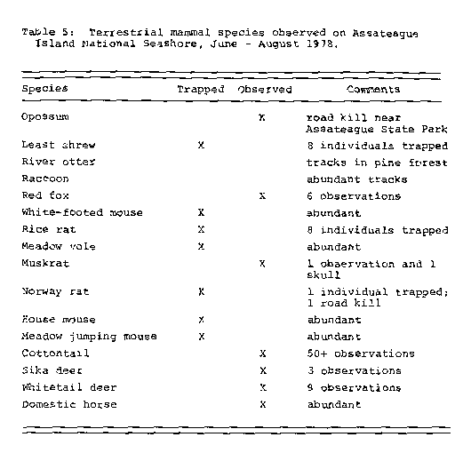

additional species reported by paradiso and Handley were not encountered; domestic cow and domestic goat. Although we observed only tracks for the raccoon and river otter, reports from local residents and park personnel indicate that both species are relatively abundant on Assateague. An intensive trapping and survey effort designed specifically around these species would be required to determine their current status on the island. None of the four species listed by Paradiso and Handley as "hypothetical" were encountered: short-tailed shrew, eastern mole, star-nosed mole, and eastern gray squirrel. Also, there were no observations of the Delmarva fox squirrel, several pairs of which have been introduced to the Chincoteague National Wildlife refuge on the Virginia portion of Assateague.

Transect Summaries

There were 1,156 captures of 450 individuals representing seven species (Table 6). The number of captures per transect ranged from 6 to l~4 (average 48). The number of individuals captured per transect ranged from 3 to SC (average l~) . The number of species captured per transect ranged from 1 on three of the transects to S on four of the transects. There was a positive relationship between the number 0£ Species captured on a transect and both the number of trap stations on that transect (r 0.62, p _ 0.002) and the number of vegetation zones represented (r 0.58, p _ 0.005). Trapping

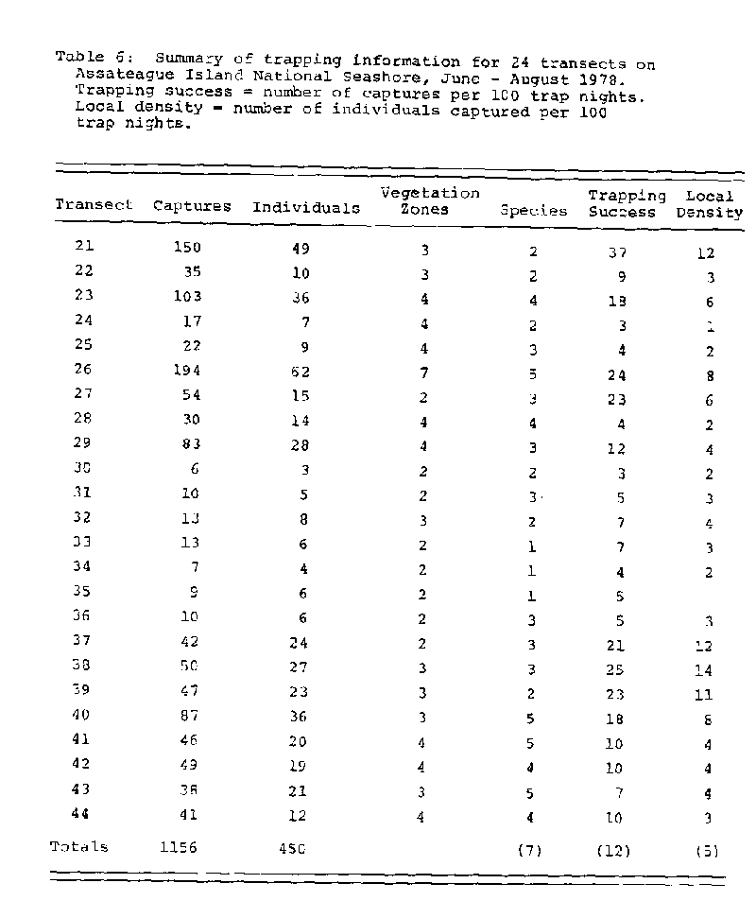
success, a standard measure of animal activity (Smith et al. 1975), ranged from 3 to 37 captures per 100 trap nights (average 12) Local density ranged from 2 to 14 individuals captured per 100 trap nights on a transect (average 5). There was essentially no relationship between the number of vegetation zones encountered and either trapping success (r = p < 0~40) or local density (r = 0.03, 2 > 0.50).

Transect Comparisons

It is apparent from inspection of Table C that the members of each pair of transects listed in Table S (21-22, 23-24, 2S-2~, 34-35) vary in the nnmber of species, trapping success and local density. These variables exhibit substantial variation even between transects located to represent a particular habitat condition. These variables also vary significantly between the three regions of the study area. Regional differences were significant for the number of species observed CF = 12.99, p < 0.001) but not for trapping success or local density. The number of species averages 2.1 per transect on the 10 central transects, 3.1 on the nine southern transects and 4.6 on the five northern transects. The two campground areas do not differ in the number of species observed, bnt both trapping success (F 7.74, p < 0.03) and local density (F S.17, p _ 0.03) were much higher in Assateague state Park than in North Beach. The State park transects also exhibited less variation in species composition than the North Beach transects. In contrast,
the North Beach transects were almost identical in the number of species observed, trapping success and local density to the seaside portions (i.e., the first 25 trap stations behind the beach) of the 16 natural, non-campground transects.

Species Summaries

The number of captures per species ranged from 1 for the Norway rat to 538 for the house mouse (Table 7) The number of individuals per species ranged from 1 for the Norway rat to 194 for the house mouse. The number of transects on which a species was captured ranqed from 1 for the Norway rat to 22 for the house mouse. In terms of the number of transects occupied, the mice were more abundant and more widely distributed than either of the rats or the least shrew. The meadow vole, house mouse, white-footed mouse and jumping mouse can be considered to have been relatively abundant during the summer of 1978- The local densities of these species averaged 1 or more individuals per 100 trap nights, and each occurred on at least 4C% of the transects. The least shrew, rice rat and Norway rat were relatively rare, with local densities of less than 1 individual per 100 trap nights and occurrence on less than 20% of the transects.

These seven species exhibited pronounced variation in the variety of habitat conditions they occupied (Table S). House mice occurred on 22 of the 24 transects and occupied essentially the full range of habitat conditions found on the transects. House mice were found in recently disturbed areas such as portions of transects 2S, 41 and 4S and on all

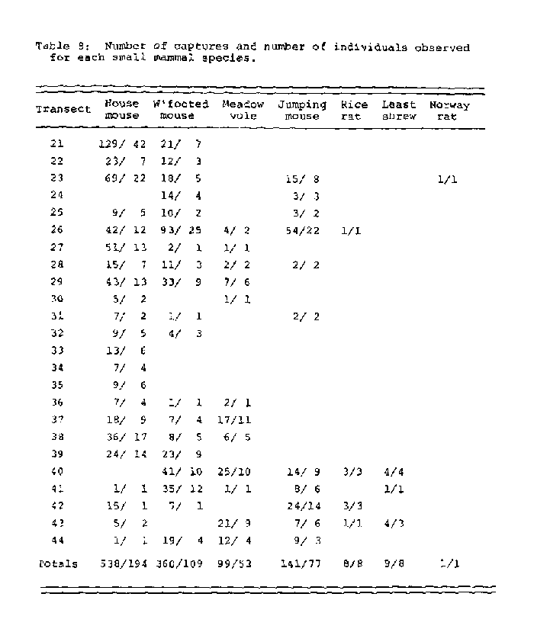
of the campground transects. White-footed mice were similar in distribution to house mice, but were seldom captured in recently disturbed areas. r4eadow jumping mice also were widely distributed but they were seldom captured in either recently disturbed areas or campground areas. Rice rats were rare and sparsely distributed. They were captured only on four of the nine transects which extended into the bayshore marsh, and were absent from disturbed areas and campgrounds. Least shrews and Norway rats appear to be particularly restricted in distribution, but these species have been trapped previously at several other locations on the r4aryland portion of the island (Dueser, unpublished). The extremely restricted distributions reported here for these species are more apparent than real.

There was evidence of breeding for house mice, meadow voles, white-footed mice and meadow jumping rrtice. The individuals captured for each of these species included males with scrotal testes, females with perforate vaginas and pregnant females. Two house mice and one meadow vole gave birth to litters while in a trap. The individuals observed for meadow voles, white-footed mice and meadow jumping mice included adult and subadult animals. The house mice included adult, subadult and juvenile animals. There were several instances of individual movement between transects. Four house mice, three meadow jumping mice and one white-footed mouse moved between transects. Two house mice moved distances in excess of 0.5 km between trapping stations.

Species-Habitat Associations

The habitat association of a species is determined from its distribution among vegetation zones (habitats). This distribution is most conservatively measured as the number of individuals observed per 100 trap stations in a zone. t~ile this measure may mask inter-transect variation for a species, it represents each species reliably overall. Since it is based on the number of individuals observed, rather than on the total number of captures recorded, local density per zone is free from any bias arising from repeated captures of trap-habituated animals at the same trap station. Local density permits direct comparison both between species within a zone and between zones for a species. The number of species observed per vegetation zone ranged from 1 for freshwater marsh (the least intensively sampled zone) to 7 for salt marsh (average 3.9) (Table 9). The number of zones exploited per species ranged from 1 for the Norway rat to S for the meadow jumping mouse (average 4.4).

Most species were distributed disproportionately among the eight vegetation zones, indicating that the species exhibit habitat preferences among the zones (Table 9). The Norway rat was captured only in salt marsh, the rice rat in salt marsh and adjacent low shrub zones, and the least shrew in the salt marshr tall shrub and herbaceous zones. It should be noted that the habitat associations for each of these three species is described here on the basis of fewer than 10 individuals. each of the four species which were
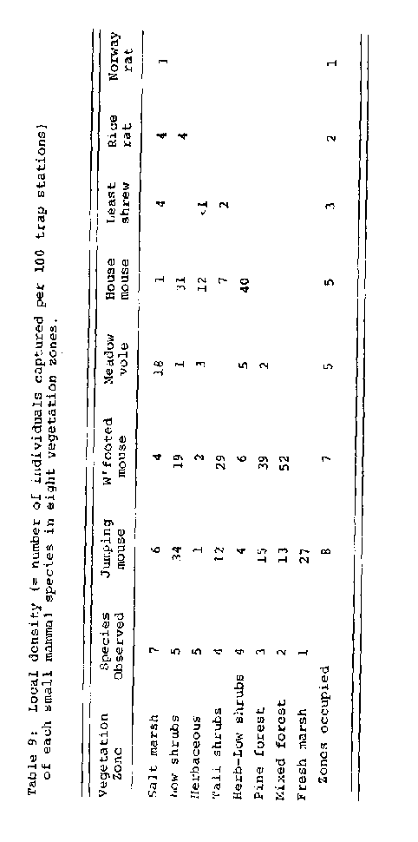

captured in at least five vegetation zones exhibited a degree of preference among the zones. The house mouse was associated primarily with the herbaceous and shrub zones. The meadow vole was primarily a salt marsh species. The white-footed mouse was associated primarily with wooded habitats, particularly the pine and mixed forest zones. The meadow jumping mouse also was associated primarily with wooded habitats, but was associated more with the shrub zones and less with the forest than was the white-footed mouse. The herbaceous zone had the lowest overall local density (pooled across species) , followed in order by the marsh, shrub and forest zones.

Species Accounts

The accounts which follow are based primarily on information collected during the summer of 1978. Additional information is included from a 2-week study conducted during July 1977 (Dueser, unpublished)₁ from a continuing study of the small mammal populations of Candleberry Trail Marsh near North Beach (L. Adkins, personal communication), and from a recent study of vertebrate species distributions on the Virginia barrier islands (Dueser, in review) . These accounts are intended to provide a general summary of information pertaining to the distribution and abundance of each species on Assateague.

Least shrew -- This is the only insectivore found on Assateague. It is found primarily in salt marsh and adjacent shrub borders. shrews were rare in the summers of 1977 and 1978, but Adkins reports that this may be one of the two or three most abundant marsh species during the late fall. The least shrew apparently is not widely distributed on Assateague. We have never captured this species further south than the Candleberry Trail Marsh. This species has not been captured on any of the Virginia barrier islands, but Hamilton (1946) trapped least shrews on Chincoteague Island.

White-footed mouse -- This was the second most abundant and widely distributed species observed during the summers of 197" and 197S. This mouse is found in most of the vegetation zones, but is most abundant in the shrub and forest zones. It is seldom captured in areas having sparse herbaceous vegetation, and, in spite of its wide distribution, does not occupy the foredune grassland. Since it is associated primarily with woody vegetation, this species appears not to be particularly opportunistic in its ability to exploit severely disturbed areas. It does, however, occupy campground areas. This species has not been captured on any of the Virginia barrier islands.

Rice rat - This is the only native rat found on Assateague. It is found prirnarily in salt ynarsh and adjacent shrub border. nice rats were rare in the summers of 1977 and l97S, and Adkins reports that they are never abundant in the vicinity of the Candleberry Trail Marsh. In spite of its low densityr this species is widely distributed on the island. Interestingly, the rice rat is the most abundant and most widely distributed rodent species on the Virginia barrier islands. On the Virginia islands this species occupies every vegetation zone, front dune-grassland through bayshore marsh. Hamilton C1946) trapped rice rats on Chincoteague Island.

Meadow vole -- Paradiso (19C9) reports this vole to be the most abundant small mammal species on Assateague, but it was only the fourth most abundant species Observed during 1970. Since this species typically exhibits a 4- or S-year cycle of abundance, extreme interannual Variation in abundance is to be expected. This species is found in a variety of habitats, but is most abundant in salt marsh and areas of dense herbaceous cover. The meadow vole is widely distributed on the island. It is able to tolerate campground conditions when adequate cover is available, as in Assateague State Park Meadow voles have been captured on three of the Virginia barrier islands. Hamilton (1946) trapped voles on Chincoteague Island.

Norway rat -- This introduced rat was rare in the summers of both 1977 and 1978. Although there was only a single capture in 1978 Con the edge of a salt marsh) , Norway rats were captured in tall shrub thickets, dense pine forest and salt marsh in 1977. Aekins reports that Norway rats are captured sporadically throughout the year in Candleberry Trail Marsh. This species seems not to exploit recently disturbed areas.

House mouse -- This introduced mouse was the most abundant and widely distributed species observed in the summers of 1977 and 1978. This species is most abundant in the herbaceous and low shrub vegetation zones, where it often occupies areas where no other species occurs. The house mouse is the most opportunistic of the species observed here, and is capable of exploiting areas which are essentially uninhabitable by the more discerning native rodent species. House mice routinely occupy recently disturbed areas (e.g., sparsely revegetated overwash fans) and campground areas. House mice were captured on three of the Virginia barrier islands.

Meadow jumping mouse -- This was the third most abundant and widely distributed rodent species observed. Jumping mice were most abundant in the shrub and forest zones, but they were observed in every vegetation zone. 'rhis species has not been captured on any of the Virginia barrier islands.

Discussion

The terrestrial mammal fauna of Assateague Island is similar in species composition to the fauna of the adjacent mainland. The missing species are mostly small mammal species which typically are found in forest habitat, such as the short-tailed shrew, the moles and the eastern grey squirrel. Assateague probably does not provide sufficient deciduous forest to sustain populations of these species.
Assateague does, however, support populations of several introduced species, including the house mouse, Norway rat, sika deer and domestic horse. The commensal house mouse and Norway rat are notoriously unsuccessful at invading natural habitats on the mainland. Their occurrence in natural habitats on Assateague is unusual by comparison with their distributions on the mainland.

The number of small mammal species found on Assateague appears to fit the species-area pattern for the Virginia barrier islands south of Assateague. The number of species found on an island (S) increased with island area (A). S varies from 0 on a small, grassland island (Little Cobb) to S on a large, forested island (Parramore) . S is related to A by the expression

S = 0.27 A ^{0.38}.
Using 7,028 ha as an estimate of the area of Assateague, including contiguous marsh, this species-area relation predicts the occurrence of eight species on the island. This predicted value is only one species greater than the number of species now known to occur on the island (7). In spite of a long history of human activity on Assateagne, the island supports a diversity of small mammal species much as expected for an island of its size along the mid-Atlantic coast.

These seven species differ greatly in distribution and abundance on Assateague. The house mouse is the most
ubiquitous species, followed closely by the white-footed mouse and meadow jumping mouse. These three species are widely distributed on the island and occur in considerable abundance at several locations. In contrast, the distributions of the least shrew, rice rat and Norway rat are patchy and relatively restricted. The absence of a species from a transect ~as not necessarily a fnnction of the habitats sampled by that transect. For example, although the least shrew and rice rat are salt marsh inhabitants. they occurred on only four of the nine transects on which salt marsh was sampled.

Six of the seven species observed occupy a variety of habitats (Plant associations) , ranging from 2 or 3 for the uncommon species and up to 7 or a for the abundant species In spite of this variety for any given species, however, each species occupies a preferred or optimal habitat within the range of habitats available: Norway rat in salt marsh, rice rat in salt marsh and adjacent low shrub borders, least shrew in salt marsh, house mouse in the herbaceous-shrub and low shrub zones, meadow vole in salt marsh, white-tooted mouse in pine forest and mixed forest, and meadow jumping mouse in low shrubs and fresh marsh. These generalities are consistent with observations for these species from 1977, and are much as expected on the basis of information from the virginia barrier islands and elsewhere. The segregation of these species into different optimal habitats rnay result from competition between species₁ frorn species differences in habitat preference or from a combination of these factors. The relative importance of each of these factors is currently under investigation (Porter and Dueser, in preparation).

The eight vegetation zones (habitats) support small mammal communities which differ in species composition and diversity. The number of species observed per zone increases in the order freshwater marsh (1), mixed forest (2), pine forest (3), herbaceous-low shrub and tall shrub (4) herbaceous and low shrub (5) and salt marsh (7). Since the zones were not sampled with equal effort (and do not occur on the island in equal abundance) , these results require cautious interpretation. Nevertheless, it appears that those habitats which are subject to relatively frequent physical stress, such as the salt marsh herbaceous vegetation zones, may actually be exploited by more species than are the 2Ones which are subject to less persistent stress, such as the pine and mixed forest zones. Assuming that the absence of dominant woody plant Species is an indicator of reduced physical stress, it seems reasonable to conclude that stress decreases from salt marsh, to herbaceous zone, to shrub zones, to forest zones. Species diversity may decrease along this same series.

Recurrent habitat stress may prevent the equilibration of species distributions and abundances, and therefore of the related community attributes (e.g., diversity), on the island. Those areas Particularly susceptible to physical disturbance are, in effect, persistently open to colonization by any species capable of exploiting that habitat. Before species interactions such as competition and predation can take effect, with a resultant decline in species diversity as less fit species are excluded locally, another bout of disturbance occurs, precluding the completion of natural processes. For stable habitats, such as the forest areas, on the other hand, the absence of frequent disturbance allows species interactions to take effect, with a resultant dcdine in species diversity. This hypothesis may explain why the northern transects were occupied by more species, on the average, than the southern transects.

From the viewpoint of mammalian species composition on a particular patch of ground, there are two principal questions of interest. First, which species is Care) most likely to invade newly vegetated areas undergoing primary succession and revegetated areas undergoing secondary Succession? The house mouse is the most likely colonizer in each case. This fugitive species is both prone to dispersal into unoccupied habitats and capable of tolerating the sparse vegetation characteristic of these habitats. Two of the areas where trapping was conducted during the summer of 1977 were heavily overwashed during the fall of 1977. There was extensive erosion and sand deposition on each site. The white-footed mouse and house mouse both were present on these areas in 1977. Only the house mouse was present in 1978, even though the white-footed mouse (and other species also) were present in adjacent undisturbed areas.

Seconar is there a succession of mammal species as the vegetation on a patch of ground undergoes succession? To the extent that the vegetation on a patch of ground undergoes succession, the mammals which occupy that patch of ground probably undergo succession also. For a xeric (non-marsh) succession, the change in mammals might be from dominance by house mice (herbaceous and herbaceous-low shrub) to dominance by house mice, white-footed mice and/or meadow jumping mice (shrub), to dominance by white-footed mice and meadow jumping mice (forest) . Obviously, this sequence may involve a stage in which the meadow vole dominates for a period of time, if there is development of a dense herbaceous stage with heavy grass.

With respect to habitat management in campground areas, these findings seem to make two important points- First, an area such as North Beach, with little development and minima1~habitat alteration, provides conditions comparable to unmanaged secondary dune and swale habitat. The North Beach campground is essentially indistinguishable from natural areas in mammal species composition and population densities. Second, an area such as Assateague State park, with dune stabilization and intensive vegetation management, provides conditions significantly different frorn unmanaged areas. Species composition is comparable to that of other areas, but population densities are much higher. Higher densities are consistent with the increase in vegetative cover resulting directly from the habitat management. Higher densities may or may not reflect other aspects of the campground environment, such as increased food availability in the form of refuse. This seems unlikely, however, since increased population densities were not observed at North neach.

BIRD STUDY

Methods

Detailed bird surveys were conducted on 10 trailsects (21, 22, 23, 25, 26, 28, 29r 41, 42 and 44). The birds on each transect were censused during the nesting season for most species (June 21 - July 1) and again during the post nesting period (July 30 August 11). An experienced observer walked slowly along each transect on three mornings during each survey period. Three transects could be surveyed during the optimal activity period between one-half hour before sunrise and mid-morning. To minimize the chance of interference, the bird surveys were conducted on mornings when no other activity was planned for a transect. Because of the difficulty of collecting reliable abundance information for birds in vegetationally diverse habitats (~mlen 1971) , two overlapping survey units were employed. Observations were recorded for a 40-m wide belt transect centered on the transect line and for a l00-rn wide belt transect centered on the transect line.

Every bird seen or heard on a transect was assigned to one of six categories of observation..

1) singing, 40~m transect,

2) non-singing, 40-rn transect,

S) singing, l00-m transect,

4) non-singing, 100-m transect,

5) in-flight over 100-rn transect, or

6) present peripherally, in vicinity of transect.

Singing birds are interpreted as evidence of nesting. Wonsinging birds are simply all other observations of individuals, frequently giving calls or notes rather than the full song characteristic of the species. The in-flight and peripheral categories establish the presence of a species in the vicinity of a transect. In terms of species identification, the six categories of observation are of comparable reliability. In terms of abundance estimates, the data from the 40-m transects are probahly more reliable than the data from the l00-m transects. These systematically collected observations were supplemented with surveys in the Assateague State park and North Beach campgrounds and with casual observations collected away from the transects and on the mainland.

Species Observed

Fifty-three species of land birds were observed (Table 10). All of these species have been reported previously from this part of Maryland (nobbins and Bystrak 1977), and all but one (cliff swallow) are on the 1976 checklist of birds for chincoteague National Wildlife Refuge on the southern end of Assateague Island. Six species were observed only casually. turkey vulture, American woodcock, crested flycatcher, bank swallow, cedar waxwing and yellow-breasted chat. Five species were observed peripherally to the transects: rock dove (pigeon) , tree swallow, cliff swallow,
Table 10: Land bird species observed on the Maryland portion of Assateague Island National Seashore, June - August 1976 Transect data are for the 100-rn width transects.

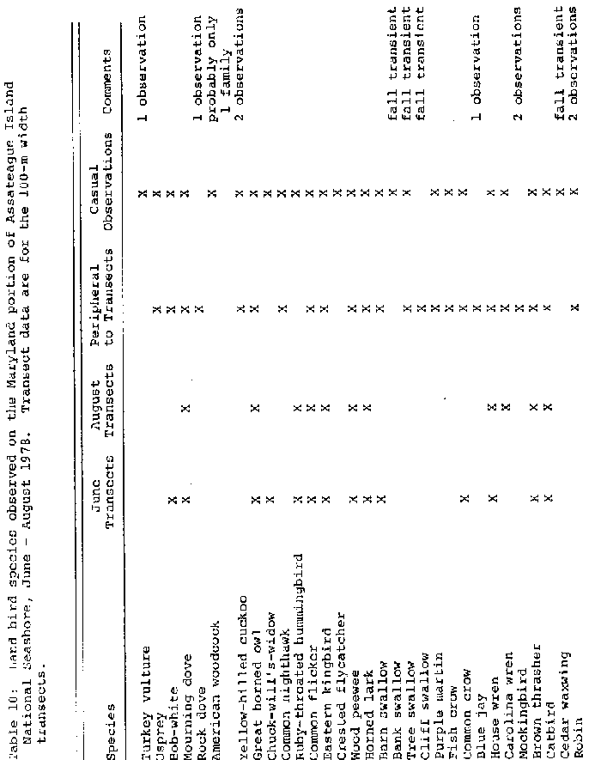blue jay and mockingbird. Eight additional species were observed both casually and peripherally: osprey, yellow-billed cuckoo, common nighthawk, purple martin, fish crow, robin, American goldfinch and sharp-tailed sparrow. Fewer than five observations were recorded for most of the species which were observed only casually or peripherally. Exceptions to this generality include the osprey, American goldfinch and fish crow, each of which was frequently observed at a distance.
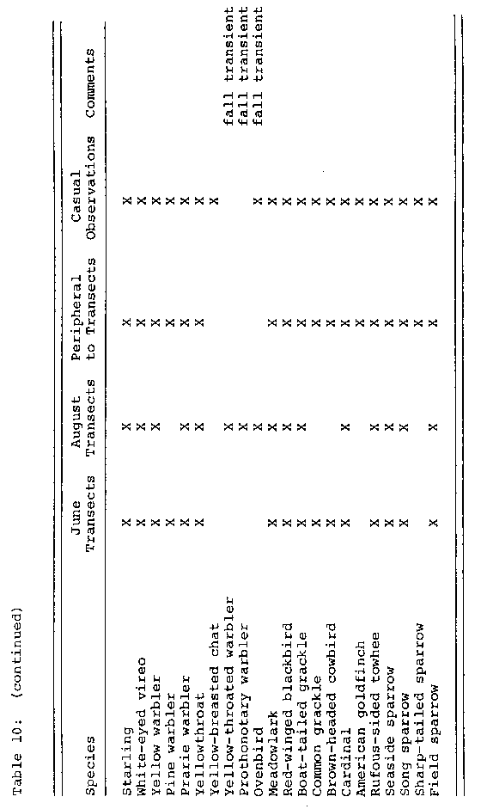
The 34 remaining species listed in Table 10 were observed on one or more transects. Together with the osprey, American goldfinch and fish crow, these species comprise the main body of the summer land bird fauna of Assateague. In terms of the number of breeding pairs observed, the American woodcock, yellow-billed cuckoo, common nighthawk, crested flycatcher, yellow-breasted chat, sharp-tailed sparrow and great horned owl probably occur in the smallest numbers. (This low abundance might be expected for the sharp-tailed sparrow, since Assateague is near the southern limit of the breeding range of this species.)

Transect Summaries

The number of species per transect is summarized by category of observation (singing, non-singing) , width of transect (40-m, 100-n) and observation period (June, August). The cumulative number of species per 40-rn transect (singing + non-singing) averaged 10.1 in June and S~3 in August

(Table ilA). The cumulative number of species per 100-m transect averaged 12.7 in June and 10.6 in August. The 1OO-m transects averaged 2.6 more species than the ⁴0-m transects in June and 2.3 more in August. Increasing the sample area by 250%, from 40 m to 100 m in wid~, increased the cumulative number of species observed per tran) ect by an average of only 26% in June and 2S% in August. In fewer than 5% of the cases was a species observed on a particular 100-rn transect but not the corresponding 40-m transect. The average number of species declined slightly between June and August, for both transect widths. Importantly, however, the June-to-August decline was much greater for the singing category than for the non~singing (Table 'in, C). singing species declined by 64% on the 40~m transects and 49% on the l00-m transects, while non-singing species declined by only 10% and 4%, respectively.

There was a consistent, positive relationship between the cumulative number of bird species observed on a transect and the length of that transect, but this relationship was statistically significant only for the August samples (40 m r = 0.77, a ~ 0.01; 100 m - r = 0.71, ~ < 0.02). There was no consistent relationship between the number of species observed and the number of vegetation zones sampled.

For purposes of comparison, bird "density" on each transect is reported here as the number of observations per hectare for each category of observation. The length (L)
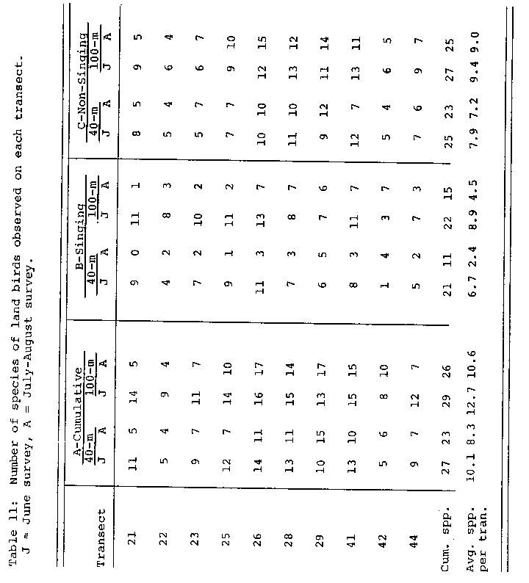
of a transect in meters is the product of 10 (N-i) a where 10 m is the distance between stations and N is the number of stations. The area CA) of each sample unit in hectares is the product 40L for the 40-m transects and loot for the l00-m transects. "Density" is then calculated for each sample unit as the ratio NIL, where N is the number of observations recorded in three passes over a transect. Since this density estimate is based on an unknown number of individuals, it is more accurately interpreted as an index of activity rather than as an index of absolute abundance. At the very least, this density estimate provides an index of bird activity along a transect.

Cumulative densities in June averaged Sl% higher on the 40-rn transects than on the l00-m transects (Table 12A). August densities averaged 29% higher on the 40-m transects than on the l00~m transects. These results suggest that the 40-rn transects actually provided more reliable information on species presence and abundance than the 100-rn transects The sampling problems associated with the narrower transects must be less severe than those for the wider transects. Cumulative densities declined by 25% between June and August. Densities of singing birds declined by 71% on the 40-rn transects and by 64% on the 100-rn transects (Table 12n, C). This decline in conspicuous breeding behavior is to be expected with the passing of the breeding season. In contrast, densities of non-singing birds actually increased by 7% on the 40-m transects and by 8% on the 100-rn transects. It is impossible to apportion this increase among post-mating adults and fledged young-of-the-year.

Campground Summaries

There were 19 species of land birds observed in and around the Assateague State Park campground and 23 observed at the North neach campground CTable 13). The species observed by North Beach included all of those observed at the state park, plus the common flicker, Carolina wren, kingbird and field sparrow. For the most part, the camp-ground species are drawn from those found coininonly or abundantly in a variety of habitats elsewhere on the island. The campground species include two conspicuous elements, those species which are found primarily in open secondary

habitats (e.g. starling, grackles, brown-headed cow-bird and bob-white) and those which are found primarily in forest habitats (e.g., catbird, house wren, rufous-sided towhee and common flicker). In both campgrounds, the distributions of most species were very patchy, probably in response to the proximity of particular vegetation associations. necause of the pine forest border along the western perimeter of the state park, more species are regularly available for casual viewing in the state park than in the North Beach area.

Species Summaries

The observations for the 40-rn transects provide the most reliable quantitative information for this avifauna.
Thirty-three species were observed on one or more of these transects (Table 14). As expected, there were more singing species observed in June (21) than in August (11). Twelve of the 21 singing species in June were non-singing in August. In contrast, the non-singing category was much more stable between sampling periods, with 25 in June and 24 in August. These is species exhibit great variation in distribution. Twenty~one of these species (64%) were observed on five or fewer transects. The five most widely distributed species were the brown thrasher (7 transects), red-winged blackbird (9), song sparrow (9) , catbird (10) and yellowthroat (10).

These 33 species also exhibited great variation in abundance (7?able 14). The cumulative number of observations per species ranged from 1 to 54 in June (average 10.1) and from 1 to 47 in August (average 7.7). There were five or fewer cumulative observations (singing + non-singing) each for 19 of the species observed in June (68%) and for 25 of the species observed in August (92%). There was a strong, positive relationship bet',,een the number of observations for a species in June and the number of observations for that species in August (r 0.~2, fl < 0.001). The species which were most abundant in June also were most abundant in August, in spite of the entry of several transient species into the community. The most abundant species (i.e., those for which there were at least 10 observations per sampling period) were the house wren, brown thrasher, catbird, yellowthroat, red~winged blackbird, rufous-sided towhee, song sparrow and field sparrcw.
NOV.-21' 97 (FRI) 14:50 TEL:8049822137 P.049
47
Table 14: Number of transects and number of observations
recorded for each species observed on one or more of the
40-rn transects. J June survey, A = July-August survey.

Number of Transects Number of Observations singing Non-singing singin~ Non-singing
Species J A J A J A J A

Bob-white
Mourning dove
Chuck-will's-widow
Ruby- throated hummingbird
Common flicker
Eastern kingbird
wood peewee
Horned lark
Barn swallow
Common crow
House wren
Carolina wren
Brown thrasher
Catbird
starling
White-eyed VirGo
Yellow warbler
pine warbler
Franc warbler
Yellowthroat
Yel1ow~throated
warbler Prothonotary warbler Ovenbird Meadowlark Red-winged blackbird float-tailed grackle Common grackle Brown-headed cowbird Cardinal Rufous~sided towhee Seaside sparrow song sparrow tield sparrow
1 0 1 0 1 0 2 0
4 a 9 6
1 0 1 0
1 0 1 1 2 0 1 1
1 2 2 2
1 0 4 1 1 0 S 1
0 1 0 1 0 a o 1
2 0 o 1 2 0 0 3
1 0 1 0
1 0 1 0
3 2 2 2 14 3 2 9
0 1 o 1
4 0 5 7 S 0 12 12
7 3 9 10 17 C 33 41
1 0 1 0
3 1 2 1 4 2 2 1
2 0 1 2 2 0 2 5
1 0 2 0 1 0 7 0
0 1 1 1 0 2 4 1
9 C 10 9 25 9 29 34
0 1 0 1
o 1
0 2
2 1 2 2
6 2 9 7
4 0 4 1
1 0
2 0
2 1
4 5
1 0
2 0
3 a
1 1
9 5
4 0
0
0
3 1 2
14 2 21
9 0 19
2
S 3
14
2 0
2 0
5 4
2 1
S 6 20 11
S S 5 0
3 20
11 10
2
2
6
as
3
0
0
1
13.--
NOV.-21' 97 (FRI) 14:50 TEL:8049822137 P.050

48

Approximately 37 (70%) of the species observed are believed to have nested on Assateague during the summer of 1S78 (Table 15). This judgment is based on the abundance of these species during the middle of the breeding season and, in most cases, observations of breeding plumage, vocal display and territorial defense. Conclusive evidence of nesting such as observations of nests, adults carrying food₁ and fledgling birds was observed for several species. The list of certain breeding species includes at least a few which were only infrequently observed: yellow-billed cuckoo, crested flycatcher and yellow-breasted chat. On the other hand, there was no evidence of nesting for several conspicuous, frequently observed species: osprey, starling and common grackle. Most of the 16 species listed as doubtful breeders were represented by only one or two observations each. At least one of the species listed as doubtful is known to breed in the immediate vicinity; the osprey occasionally nests on channel markers and duck blinds in the bays behind As sateague.

Species-Habitat Associations

The habitat association(s) of a species is determined from its distribution among vegetation zones on the 40~m transects. This distribution is most meaningfully expressed as the cumulative number of observations (singing + nonsinging) of a species in a zone. While this measure may
NOV.-21' 97 (FRI) 14:50 TEL:8049822137 P.051
49
Table 15: Breeding status of 53 species of birds on Assateague
Island National Seashore during the summer of l97S.
Breeding Breeding Breeding
doubtful probable certain

Turkey vulture osprey
Rook dove Bank swallow Tree swallow Cliff swallow purple martin Blue jay Mockingbird cedar waxwing Robin starling Yellow-throated
warbler Prothonotary warbler Ovenbird
common grackle

American woodcock
Great horned owl
chuck-will~ s-widow
Common crow
Carlina wren

Bob-white
Mourning dove
Yellow-billed cuckoo
Common nighthawk
Ruby-throated
hummingbird
Common flicker
Eastern kingbird
Crested flycatcher
wood peewee
Horned lark
Barn swallow
Fish crow
House wren
Brown thrasher
Catbird
White-eyed virco
Yellow warbler
Pine warbler
prarie warbler
Yellowthroat
Yellow-breasted chat
Meadowlark
Red-winged blackbird
Boat-tailed grackle
Brown-headed cowbird
Cardinal
American goldfinch
Rufous-sided towhee
seaside sparrow
song sparrow
sharp-tailed sparrow
Field sparrow
NOV.-21' 97 (FRI) 14:50 TEL:8049822137 P.052

50

mask inter-transect variation for a species, it represents each species reliably overall. The information by transect for any given species includes too few observations to be reliable. The number of species observed per vegetation zone ranged from C for salt marsh to 20 for tall shrub thicket (average 14.3) (Table 16). The number of zones exploited per species ranged from 1 for nine species to 7 for only two species (average 3.0).

Every species was distributed disproportionately among the seven vegetation zones in which bird snrveys were condncted, indicating that the species exhibit different habitat preferences among the habitats available on Assateagne. Based on the inforrnatian in Table 16, most species can be assigned to a characteristic habitat type:

herbaceons or herbaceous-low shrub -- song sparrow, meadowlark, seaside sparrow, field sparrow, eastern kingbird, horned lark, bob-white

low shrub or tall shrub thicket --. yellowthroat, red-winged blackbird, boat-tailed grackle, brown thrasher, cardinal, rnfous-sided towhee, prarie warbler, mourning dove, brown-headed cowbird, yellow warbler

pine or mixed forest -- catbird, house wren, rubythroated hummingbird, white-eyed virco, common flicker, wood peewee,, pine warbler.

Three of the infrequently observed species can be character ized as shrub thicket species: barn swallow, common grackle and starling. The remaining six infreqnently observed species are primarily forest species: ovenbird, chuck-will's~widow, Carolina wren, yellow-throated warbler, prothonotary warbler and common crow.
NOV.-21' 97 (FRI) 14:51 TEL:8049822137 P.053

51

Table 16! species-habitat associations of the SS species of land birds observed on one or more of the 40-rn transects. Tabled values are the cumulative number of observations for a species in a zone. Underlined values indicate that the species exhibited breeding behavior in that zone.
Species a H-L L T P M S zones
Yellowthroat 7 40 16 25 S S a 7
Red-winged blackbird S W3 S 2 T 6 7
Song sparrow 15 24 9 - 3 5
Boat-tailed grackle 4 6 - C 1W 4
Meadowlark T 1 3
Seaside sparrow 1 2
firown thrasher 1 11 T 14 1 1 6
Catbird 2 Th5 S 30 2W 20 6
House wren 1 6 W a S
Cardinal 1 1 1 1 5
Rufous-sided towhee 3 1 16 15 T S
Ruby-throated 1 3 2
hummingbird
white-eyed virGo 1 6 2 3
Common flicker I s 2
Prarie warbler 3 4 2
Ovenbird I 1 2
wood peewee 3 1 2
Pine warbler 7 T 2
Field sparrow 1 15 3 6 I - S
Eastern kingbird 1 4 I 1 4
Mourning dove 4 1 8 2 4
Chuck-will's-widow 1 1
Carolina wren 1 1
nrown-headed cowbird 2 3 5 S
Yellow warbler - 2 4 3 3
Yellow-throated I 1
warbler
prothonotary warbler 2 1
Horned lark 4 1 2
Barn swallow - I 1
Common grackle 2 1
nob-white a 1
Common crow T 1
starling 1 1
Zone Totals 17 16 12 20 15 14 6
3- 7 6)
2/
NOV.-21' 97 (FRI) 14:51 TEL:8049822137 P.054

52

wseciesAcconnts

The species accounts which follow slimmarize the information collected for each of the 53 species of land birds observed in the summer of 1978. "Abundant" species occur in a variety of habitats or are particularly numerous in a few habitats. "Common" species are slightly less numerous and/or somewhat more restricted in their habitat associations. ~he abundant and common categories comprise the bulk of the Assateague summer avifauna. "Frequent" species would normally be encountered in appropriate habitats, and add a predictable secondary component to the avifauna. "Occasional species are regularly present but occur in small numbers, and thus represent an element of the fauna which is not readily observable. Infrequently observed species, listed with their dates of observation, are presumed not to have nested on the Maryland portion of Assateague during 1978.

Turkey vulture -- one sighting on June 22.

Osprey -- occasional nester on channel markers and duck blinds in the bays behind Assateague. Frequently observed hunting over surf.

nob-white -~ coinmon in grassland and grass-shrub rnixture~ occasional in pine forest.

Mourning dove -- occasional nester in shrub thickets and pine forest. Frequently observed feeding in grassland areas.

Rock dove -- one sighting on June 25.
NOV.-21' 97 (FRI) 14:51 TEL:8049822137 P.055

53

American woodcock -- status undetermined, but apparently uncommon. Occasional dawn sightings of 1-4 birds in road near entrance to Assateague State park.

Yellow-billed cuckoo -- occasional in forest habitat.

Great horned owl -- occasional in pine forest. Occasionally observed hunting over more open habitat.

Chuck-will's-widow -- frequent in and near pine forest.

Common nighthawk -.. occasional on vegetated secondary dunes. More common on the island than on the adjacent main-land.

Ruby-throated hummingbird -~ frequent in pine forest and forest borders.

Common flicker -- common in shrub thickets and pine forest. Observed feeding in a variety of habitats.

Eastern kingbird -- frequent in grass-shrub mixture, shrub thickets and marsh borders.

Crested flycatcher -- occasional in pine and mixed
forest.

Eastern wood neewee -- occasional in pine and mixed forest.

Horned lark -- frequent in grassland habitat. More common on the island than on the adjacent mainland.

Barn swallow -- abundant over entire island. ?requent nester on wash houses and other buildings.

flank swallow -- fall transient. One sighting on July

30.

Tree swallow -- fall transient. Occasional before August 1, but increasingly abundant after August 1.
NOV.-21' 97 (FRI) 14:51 TEL:8049822137 P.056

54

Cliff swallow --August 11.

purple martin --island on June 22 and anne 25.

fall transient. Two sightings on

two birds sighted feeding high above

Fish crow -- abundant throughout.

Common crow -- occasional in a variety of habitats.

nine £ja --. status undetermined. Three sightings on June 25.

House wren -- occasional in shrub thickets and common in pine forest.

Carolina wren -- status undetermined. A single singing bird sighted near Candleberry Trail on June 30. Species has suffered a drastic decline in numbers during the past two severe winters. The apparent rarity of the species on Assateague may reflect this regional decline.

Mockingbird -- status undetermined. Two sightings of non-singing individuals on June 30 and July 1.

Brown thrasher -- frequent in shrub thickets and pine forest. One of the most conspicuous species in the vicinity of campgrounds.

Catbird -- abundant in shrub thickets and pine forest.

Cedar waxwing -- tall transient. One sighting on August 11.

Robin -- status undetermined. Two sightings of non-singing individuals, in the North Beach campground on June 21 and in pine forest on June 30.
NOV.-21' 97 (FRI) 14:52 TEL:8049822137 P.057

55

Starlincr -- frequent in open habitat. Often observed in foraging groups of 5-10 individuals.

White-eyed virGo -- frequent in forest and forest borders.

Yellow warbler -- frequent in shrub thickets aria forest borders.

Pine warbler -- frequent in pine forest.

Prarie warbler -- occasional in forest and forest borders.

Yellowthroat -- abundant in shrub thickets and forest borders.

Yellow-breasted chat -- two sightings in pine forest on June 25 and June 2(3.

Yellow-throated warbler -- fall transient. One sighting on August 3.

prothonotary warbler -- fall transient. Two sightings on July 31.

Ovenbird -- fall transient. Three sightings on August 2, S and 7.

~astern meadowlark -- abundant throughout in open habitat.

Redwing blackbird -- abundant throughont in open habitat. One of the most conspicuous species on the island, particularly around campgrounds.

float-tailed grackle -- abundant throughout in open habitat.

Common grackle -- occasional in less disturbed areas, common in vicinity of campgrounds.

Brown-headed cowbird -- common throughout.

Cardinal -~ occasional in shrub thickets and mixed forest.
NOV.-21' 97 (FRI) 14:52 TEL:8049822137 P.058

56

American goldfinch frequent in a variety of habitats.

Rufous-sided towhee -- common in shrub thickets and forest areas.

Seaside sparrow -- common in salt marsh.

Song sparrow -- abundant in shrub thickets (particularly evergreen shrubs) and forest borders.

sharp-tailed sparrow -- occasional in salt marsh and marsh borders. seems to have an affinity for Juncus roemerianus marsh.

Field sparrow -- common in shrub~thickets and forest borders.

Discussion

The species of land birds which were frequently observed on Assateagne also were numerous on the adjacent mainland. Several of these numerous species occupy a variety of habitats:

yellowthroat, red-winged blackbird, fish crow, song sparrow and catbird. Other numerous species occupy only a few particularly abundant habitats, such as grassland or grass-shrub mixture: eastern kingbird, horned lark, brown thrasher, eastern meadowlark and boat-tailed grackle. As a rule, then, the abundant species either tolerate a broad range of habitat conditions or specialize on habitat conditions which just happen to be well represented on Assateague.

The species which were seldorn observed on Assateagne comprise three groups. The first group includes seven transient
NOV.-21' 97 (FRI) 14:52 TEL:8049822137 P.059

57

species observed only in late July and August: tree swallow, bank swallow, cliff swallow, cedar waxwing, prothonotary warbler, yellow-throated warbler and ovenbird- Assateague does not support breeding populations of these species. There were only one or two individuals observed for each of these species except the tree swallow, which was abundant in August. The second group inclndes two species which were more common on the island than on the adjacent mainland₁ the common nighthawk and the horned lark. For the nighthawk, at least, the open, sandy habitat available on the island is more suitable for nesting than is most of the mainland habitat. Although nighthawks have adapted well to nesting on gravel rooftop terraces in metropolitan areas, the occurrence of this species in natural habitats on Assateague has especial appeal.

The third group includes those species which were conspicuously more common on the mainland than on the island. This group includes the turkey vulture, rock dove, yellow-billed cuckoo, crested flycatcher, purple martin, blue jay, mockingbird, robin and yellow-breasted chat. Three transient species could also be included in this group prothonotary warbler, yellow-throated warbler and ovenbird. Several occasional species also occur more commonly on the mainland, SLncluding the wood peewee, common crow, prarle warbler, common grackle and cardinal. The rarity of the blue jay, mockingbird and robin is particularly noteworthy since these species are so abundant on the mainland. The one or two observations for each of these species were non-vocal
NOV.-21' 97 (FRI) 14:52 TEL:8049822137 P.060

SB

individuals, which may indicate that they were young-of-theyear, fledged on the mainland and occurring on the island as post-juvenile dispersers.

Based on casual observations of birds on the mainland, there were many mainland species which were never observed on the island. conspicuously missing are many forest-dwelling species. The forest on the Maryland portion of Assateague is limited in both extent and development. A deciduous element is conspicuously lacking in all but a few scattered areas. 'This may explain the absence of cavity-nesting bird species such as the chickadees and woodpeckers and the paucity of other species such as the crested flycatcher. The aggressive house wren, on the other hand, is abundant. The complete absence of such a widespread and adaptable species as the indigo bunting is similarly intriguing.

These results suggest three possible management actions to either improve the status of selected species or at least improve the "viewability" of certain species to park visitors. First, osprey nesting platforms could be erected in the bays behind Assateague. The presence of this large bird of prey adds a majestic component to the Assateague avifauna. ospreys are capable of living at relatively high densities, given the availability of secluded nesting areas. osprey nesting on the island itself is almost certainly an exceptional occurrence. second, nest boxes could be erected for swallows and purple martins. such boxes might be particularly beneficial for the rnartins, since this species appears to be
NOV.-21' 97 (FRI) 14:53 TEL:8049822137 P.061

59

much less abundant on Assateague than on the ad~acent mainland. Third, the promotion of increased vegetation diversity in campground areas should promote greater bird diversity in these areas. In particularr the planting of pine and tall shrub borders should promote the occurrence of at least some forest species, such as the warblers, in the vicinity of park visitors.
NOV.-21' 97 (FRI) 14:53 TEL:8049822137 P.062

60

LITERATURS: CITED

Boyce, S. S. 1954. rhe salt spray community. Ecol. Monogr. 24: 29-67.

Dueser, R. D. and w. C. Brown. In review. Ecological correlates of insular rodent diversity.

Emlen, J. T. 1971. Population densities of birds derived from transect counts. Auk 88: 320-S42.

Hamilton, w. J., Jr. 1946. Habits of the swamp rice rat, aryzomys palustris (Harlan). Amer. Mial. Nat. 36:
730-7S6.

Higgins, E. A. 'T., R. fl. Rappleyc and R. C. srown. 1971. The flora and ecology of Assateague Island. Univ. Md. Agric. Expt. Sta. null. A-l72.

Martin, N. E. 1959. The vegetation of Island Beach State ?ark, New Jersey. Ecol. Monogr. 29: 1-46.

oosting, H. J. 1954. Ecological processes and vegetation of the maritime strand in the southeastern United States. not. Rev. 20: 226-262.

oosting, H. J. and W. D. Billings. 1942. Factors affecting vegetation zonation on coastal dunes. Ecology 2S:
131-142.

Paradiso₁ a. L. 1969. The mammals of Maryland. N. Amer. Fauna 66! 1-193.

paradiso, J. L. and C. 0. Handley, Jr. 1965. Checklist of mammals of Assateague Island. Chesapeake Sci.
6. 167-171.

Robbins, C. S and n. flystrak. 1977. Field list of the birds of Maryland (2nd ed.). Md. Avifauna No. 2, Nd. ornithological Society.

Shure, D. J. 1970. Ecological relationships of small mammals in a New Jersey barrier beach habitat.
a. Mammal. 51! 267-278.

Shure, D. J. 1971. Tidal flooding dynamics its influence on small mammals in barrier beach marshes. Amer. Midl. Nat. 85: 36-44.

